**Lecture 3. Elementary excitations in crystals.**

*Solutions of the problems to Lecture 2*.

1. a) ;

b) ;

c) .

2. For the coherent distribution:

;

(reminder: )

For the thermal distribution:

Let .

.

Thus,

.

3. For the coherent distribution:

.



4.

Let .

.

.

Note that  and



For the thermal distribution:





**3.1 Optical transitions in semiconductors.**

We remind here the most essential features of the structure of optical transitions in semiconductors. [1]

|  |  |  |  |
| --- | --- | --- | --- |
|  | Fermi level | Energy gap width | Conductivity (S m-1) |
| metals | Inside the band | any | Up to 6.3 107 (silver) |
| semiconductors | Inside the gap | < 4 eV | Varies in large limits |
| dielectric | Inside the gap | 4 eV | Can be as low as 10-10 |

**Table 3.1 Classification of solids.**

It is well-known that the discrete electronic levels of individual atoms form large *bands* in crystals where thousands of atoms are assembled in a periodic structure. There are also gaps between the allowed bands where no electronic states exist in an ideal infinite crystal. Those crystals which have a Fermi level[2] inside one of the allowed bands are *metals*, while the crystals having a Fermi level inside the gap are *semiconductors* or *dielectrics*. The difference between semiconductors and dielectrics is quantitative: the materials where the band gap containing the Fermi level is narrower than about 4 eV are usually called semiconductors, the materials with wider band gaps are dielectrics. In this Chapter we consider only semiconductor crystals.

The eigen-functions of electrons inside the bands have a form of so-called *Bloch waves*.

The concept of the Bloch waves was developed by a Swiss physicist Felix Bloch in 1928, to describe the conduction of electrons in crystalline solids. **The Bloch theorem** states that a wave-function of an electronic eigen-state in an infinite periodic crystal potential  can be written in form:

, (3.1.1)

where  (called *Bloch amplitude*) has the same periodicity as the crystal potential, **k** is so-called *pseudo-wave vector* of an electron (further we shall omit “pseudo” while speaking about this quantity), *n* is the index of the band.

Substitution of the wave-function (3.1.1) into the Schroedinger equation for an electron propagating in crystal

, (3.1.2)

with  being the free electron mass, one obtains an equation for the Bloch amplitude:

, (3.1.3)

where . Consideration of the operators in the parentheses as a perturbation constitutes the ** method of the perturbation theory** which readily allows to find the shape of the electronic dispersion in the vicinity of **k**=0points of all bands, which appears to be strongly different from the free electron dispersion in vacuum. Approximation

 (3.1.4)

is called the *effective mass approximation* with  being the electron effective mass in *n*-th band[3]:

. (3.1.5)

The frequencies and polarization of the optical transitions in direct gap semiconductors are governed by the energies and dispersion of two bands closest to the Fermi level[4], referred to as the conduction band (first above the Fermi level) and the valence band (first below the Fermi level).

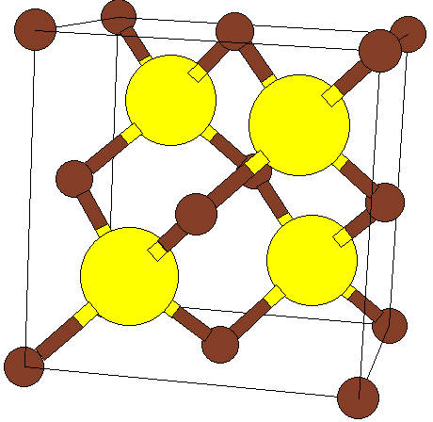 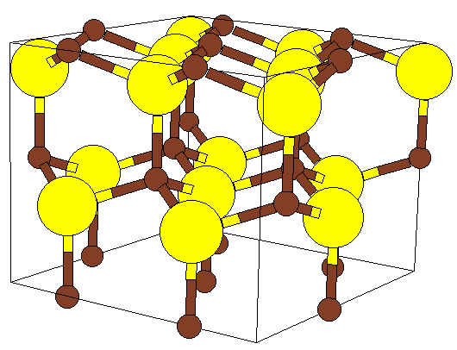

b)

a)

**Figure 3.1.1** Zinc-blend (a) and wurtzite (b) crystal lattices.

Semiconductors can be divided into direct band gap and indirect band gap ones. In indirect gap semiconductors (like Si and Ge) the electron and hole occupying lowest energy states in conduction and valence bands cannot directly recombine emitting a photon due to the wave-vector conservation requirement. While a weak emission of light by these semiconductors due to phonon-assisted transitions is possible, they can hardly be used for fabrication of light-emitting devices and studies of light-matter coupling effects in microcavities. In the following, we shall only consider the direct gap semiconductor materials like GaAs, CdTe, GaN, ZnO etc. Most of them have either a zinc-blend or a wurtzite crystal lattice[5] (see Figure 3.1.1). In zinc-blend semiconductors, the valence band splits into three sub-bands referred to as the heavy-hole, light-hole and spin-off bands (see Figure 3.1.2). At **k**=0 the heavy and light hole bands are degenerated in bulk crystals, while this degeneracy can be lifted by strain or external fields. In the wurzite semiconductors the valence band is split into three non-degenerated subbands referred to as A, B, and C bands.

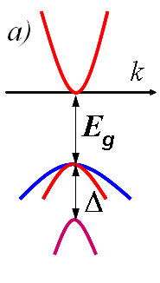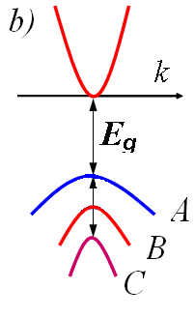

**Figure 3.1.2** Schematic band structure of a zinc-blend semiconductor (a) with a conduction band (on the top), degenerated heavy and light hole bands (in the middle) and the spin-off band (in the bottom) and a wurtzite semiconductor with A, B, and C valence subbands. .

Optical absorption spectra in semiconductors are governed by the density of electronic states in the valence and conduction bands, , where *n* is the number of quantum states per unit area. In bulk crystals, inside the bands the density of states behaves as , which results in the corresponding shape of the interband absorption spectra. Besides this, at low temperatures the absorption spectra of semiconductors exhibit sharp peaks below the edge of interband absorption (i.e. at frequencies , where  is the band-gap energy). These peaks manifest the resonant light matter coupling in semiconductors. They are caused by the excitonic transitions which will remain in the focus of our attention throughout this book.

**3.2. Excitons in semiconductors.**

**Frenkel and Wannier-Mott excitons.**

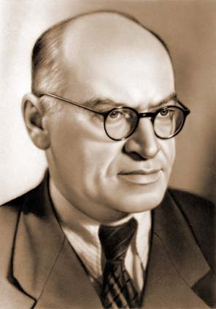

Ya.I. Frenkel (1894-1952)

In the late 1920s narrow photoemission lines have been observed in the spectra of organic molecular crystals by A. Kronenberger and P. Pringsheim[6] and I. Obreimov and W. de Haas[7]. These data were interpreted by the Russian theorist Yakov Frenkel who introduced the concept of excitation waves in crystals in 1931[8] and invented the term “exciton” in 1936[9]. By definition, exciton is a **Coulomb-correlated electron-hole pair**. Frenkel treated the crystal potential as a perturbation to the Coulomb interaction between an electron and a hole which belong to the same crystal cell. This method is most effective in organic molecular crystals. The *binding energy*of Frenkel exciton (i.e. the energy of its ionisation to a non-correlated electron hole couple) can be of the order of 100-300 meV. Frenkel excitons have been searched for and observed in alkali kalides by L. Apker and E. Taft[10] in 1950. At present they are widely studied in organic materials where they dominate the optical absorption and emission spectra. In the end of 1930s the Swiss physicist Gregory Hugh Wannier (1911-1983) and English theorist Sir Nevil Francis Mott have developed a concept of exciton in semiconductor crystals,[11] where the rate of electron and hole hopping between different crystal cells much exceeds the strength of their Coulomb coupling with each other. Unlike Frenkel excitons, Wannier-Mott excitons have a typical size of the order of tens lattices constants and a relatively small bidning energy (typically, a few meV).

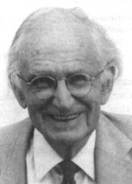

Sir N.F. Mott (1905-1996)

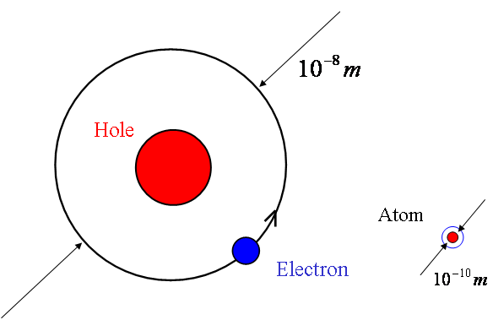

**Figure 3.2.1** Wannier-Mott exciton is the solid state analogy of a hydrogen atom, while they have very different sizes and binding energies. Unlike atoms, the excitons have a finite life-time.

Here we shall only discuss the Wannier-Mott excitons in semiconductor structures. Such excitons can be conveniently described within the *effective mass approximation* which allows to neglect the periodic crystal potential and describe electrons and holes as free particles having a parabolic dispersion and characterized by effective masses dependent on the crystal material. Usually, the effective masses of carriers are lighter than the free electron mass in vacuum . For example, in GaAs the electron effective mass is , the heavy-hole mass is .

Consider an electron-hole pair bound by Coulomb interaction in a crystal having a dielectric constant . The wave-function of relative electron-hole motion  can be found from the Schroedinger equation analogous to one describing the electron state in a hydrogen atom:

 , (3.2.1)

where  is the Laplacian operator, ,  is the distance between electron and hole. The solutions of Eq. (3.1.1) are well known. They correspond to the eigen functions of the hydrogen atom with two substitutions :

, . (3.2.2)

For example, the wave-function of the 1*s* state of exciton reads:

, (3.2.3)

where the Bohr radius

. (3.2.4)

The binding energy of the ground exciton state is

. (3.2.5)

Given the difference between the reduced mass  and the free electron mass, and taking into account the dielectric constant in the denominator, one can estimate that the exciton binding energy is about three orders of magnitude less than Rydberg constant. Table 3.2 shows the binding energies and Bohr radii for Wannier-Mott excitons in different semiconductor materials.

| Semiconductor crystal | *Eg*, eV |  | , meV | , Å |
| --- | --- | --- | --- | --- |
| PbTe* | 0.17 | 0.024/0.26 | 0.01 | 17000 |
| InSb | 0.237 | 0.014 | 0.5 | 860 |
| Cd0.3Hg0.7Te | 0.257 | 0.022 | 0.7 | 640** |
| Ge | 0.89 | 0.038 | 1.4 | 360 |
| GaAs | 1.519 | 0.066 | 4.1 | 150 |
| InP | 1.423 | 0.078 | 5.0 | 140 |
| CdTe | 1.606 | 0.089 | 10.6 | 80 |
| ZnSe | 2.82 | 0.13 | 20.4 | 60 |
| GaN*** | 3.51 | 0.13 | 22.7 | 40 |
| Cu2O | 2.172 | 0.96 | 97.2 | 38**** |
| SnO2 | 3.596 | 0.33 | 32.3 | 86**** |

* Strongly anisotropic conduction and valence bands, direct transitions far from the center of the Brillouin zone.   
  ** In the presence of magnetic field of 5T.   
  *** А exciton in hexagonal GaN.   
  **** The ground state corresponds to an optically forbidden transition, data given for n=2 state.

**Table 3.2** Band gap energy (), electron effective mass, binding energy and Bohr radius of excitons in different semiconductor crystals (from R.P. Seysian, Window to Microworld, **5**, 6 (2002)).

The exciton excited states form a number of hydrogen-like series. Observation of such a series of excitonic transitions in the photoluminescence spectra of CuO2 in 1951 was the first experimental evidence for Wannier-Mott excitons (see Figure 3.2.2). This discovery has been made by a Russian spectroscopist Evgeniy Gross who worked in the same institution (Ioffe Physico-Technical institute in Leningrad) with Ya.I. Frenkel at that époque.

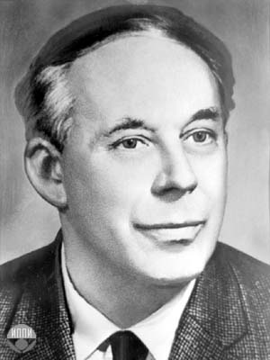

E.F. Gross (1897-1972)

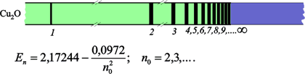

**Figure 3.2.2** Hydrogen-like “yellow” series in emission of Cu2O observed by Gross and Zakharchenia and its numerical fit (from E.F. Gross, B.P. Zakharchenia, and N.M. Reinov, Doklady of the Academy of Sciences of USSR **111**, 564 (1954)).

**Excitons in confined systems**

Since the beginning of 1980s, the progress in the growth technology of semiconductor heterostructures allowed to study Wannier-Mott excitons in confined systems including quantum wells, quantum wires and quantum dots. The main idea behind invention of heterostructures was to create artificially potential wells and barriers for electrons and holes combining different semiconductor materials. The shape of potential in conduction and valence bands is determined in these structures by positions of the corresponding band edges in the materials used as well as by the geometry of the structure. The *band engineering* in semiconductor structures by means of the high-precision growth methods has allowed to create a number of electronic and opto-electronic devices including transistors, diodes and lasers. It has also permitted discovery of important fundamental effects including the integer and fractional quantum Hall effects, Coulomb blockade, light-induced ferromagnetism etc.

The large size of Wannier-Mott excitons makes them strongly sensitive to nanometer-scale variations of the band edges positions which can be easily achieved in modern semiconductor nanostructures. The energy spectrum and wave-functions of quantum confined excitons can be strongly different from those of bulk excitons. Here we consider by means of an approximate but efficient variational method the excitons in quantum wells, wires and dots (see Figure 3.2.1). We shall use the effective mass approximation. Speaking about wave-functions we shall always mean the envelope functions neglecting the Bloch amplitudes of electrons and holes. Note that in these examples we neglect the complexity of the valence band structure and consequent anisotropy of the hole effective mass which sometimes strongly affect the excitonic spectrum in real semiconductor systems.

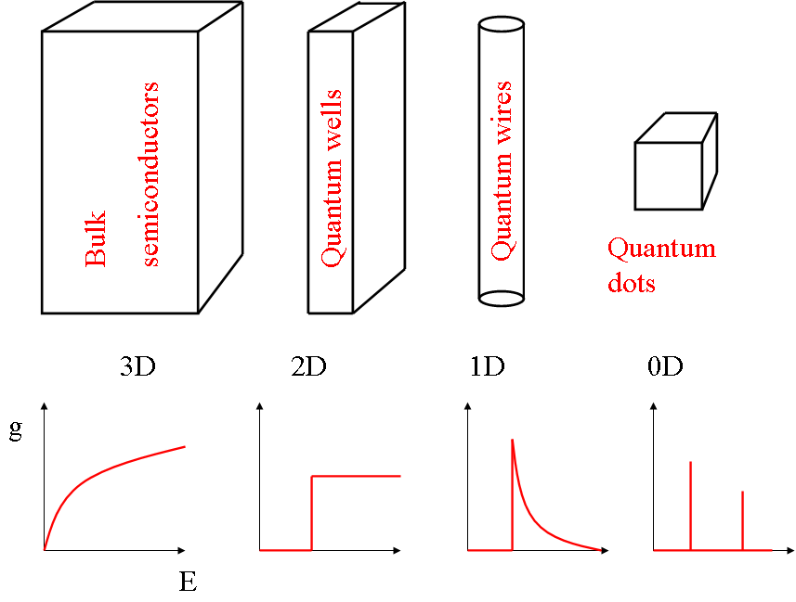

**Figure 3.2.1** Reduction of the dimensionality of a semiconductor system from 3D to 0D from a bulk semiconductor to a quantum dot. The electronic density of states , where *dN* is the number of electron quantum states within the energy interval *dE*, changes drastically between systems of different dimensionalities as is schematically shown in this figure. This variation of the density of states is very important for light emitting semiconductor devices.

**3.3 Excitons in Quantum wells**

The Schroedinger equation for an exciton in a quantum well (QW) can be written in form

 , (3.3.1)

where , the Laplacian  depends on electron, hole coordinates, respectively,  is the confining potential for electron, hole, *z*-axis is the growth axis of the structures. Exact solving of Eq. (3.3.1) is not an easy task. We shall solve it variationally over a class of trial functions having a form

, (3.3.2)

where  is the exciton center of mass coordinate,  is the in-plane radius-vector of electron and hole relative motion (). Four components of the trial function (3.3.2) describe the exciton center of mass motion, the relative electron-hole motion in the plane of the QW, electron and hole motion in normal to the plane direction, respectively. The factorization of the exciton wave function (3.3.2) makes sense when the QW width is less or comparable to the exciton Bohr diameter in the bulk semiconductor. In this case, electron and hole are quantized independently of each other. On the other hand, in larger QWs, one can assume that the exciton is confined as a whole particle and keeps the internal structure of a 3D hydrogen atom. Here and further we shall consider narrow QWs where Eq. (3.3.2) represents a good approximation. The four terms which compose the exciton wave-function are normalized as follows:

. (3.3.3)

After substitution of the trial function (3.3.2) and integration over , Eq. (3.3.1) becomes:

, (3.3.4)

where,  , , ,

,  is the excitonic momentum,  for the ground state.

Eq. (3.3.4) can be transformed into a system of three coupled differential equations each defining one of the components of our trial function. The equation for is obtained by multiplication of both parts of Eq. (3.3.4) by  and integration over  and . This yields:

, (3.3.5)

whereis the exciton binding energy. The electron and hole confinement energies , and wave-functions , can be obtained by multiplying of Eq.(3.3.9) by  and integration over  and :

. (3.3.6)

In the ideal 2D case,  and equation (3.3.5) transforms into

, (3.3.7)

which is an exactly solvable 2D hydrogen atom problem. For the ground state

, (3.3.8)

where , *aB* being the Bohr radius of the three-dimensional exciton given by Eq. (3.2.4). The binding energy of the two-dimensional exciton exceeds by a factor of 4 the bulk exciton binding energy:

 . (3.3.9)

For the realistic QWs, Eqs. (3.3.5), (3.3.6) still can be decoupled if the Coulomb term in (3.3.6) is neglected. This allows to find the functions  independently from each other and . Solving (3.3.5) with a trial function , where is a variational parameter, one can express the binding energy as:

 . (3.3.10)

Maximization of  finally yields the exciton binding energy in a QW, which ranges from  to  and depends on the QW width and barrier heights for electrons and holes. The binding energy increases if the exciton confinement strengthens. That is why the dependence of the binding energy on the QW width is non-monotonic: for wide wells the confinement increases with the decrease of the QW width, while for ultranarrow wells the tendency is inverted due to tunneling of electron and hole wave functions into the barriers (Figure 3.3.2).



**Figure 3.3.2** Exciton binding energy as a function of the QW width (schema). The insets show the QW potential and wave functions of electron (blue) and hole (red) for different QW widths.

**SUPPLEMENTARY MATERIAL**

**Quantum wires and dots**

Variational calculation of the ground exciton state energy and wave-function in quantum wires or dots can be done using the same method of separation of variables and decoupling of equations as for the QWs. There exists a number of important peculiarities of wires and dots with respect to wells, however.

For a wire, the Schroedinger equation for the wave-function of electron-hole relative motion , where *z*-axis is the axis of the wire, writes:

, (3.3.11)

where  is the kinetic energy operator for relative motion along the axis of the wire,  is the electron, hole wave-function in the plane normal to the wire axis,  is the exciton binding energy in the wire. Despite visible similarity to Eq. (3.3.5) for electron-hole relative motion wave-function in a QW, Eq. (3.3.11) has a different spectrum and eigen-functions. As a quantum particle in 1D Coulomb potential has no ground state with a finite energy, the exciton binding energy in a quantum wire is drastically dependent on spreading of the functions  and can, theoretically, have any value between  and infinity. The trial function  cannot be exponential (as it would have a discontinuous first derivative at *z*=0 in this case). The Gaussian function is a better choice in this case. Usually, realistic quantum wires do not have a cylindrical symmetry (most popular are “T-shape” and “V-shape” wires, see Figure 3.3.3), which makes computation of  a separate not-easy task. Moreover, the realistic wires have a finite extension in *z*-direction which is comparable with the exciton Bohr-diameter in many cases. Even if the wire is designed to be much longer than the exciton dimension, inevitable potential fluctuations in *z*-direction lead to the exciton localization. This makes realistic wires similar to elongated quantum dots (QDs).



**Figure 3.3.3** Cross-sections of V-shape (a) and T-shape (b) quantum wires(from A. Di Carlo, et al., Phys. Rev. B**57**, 9770 (1998)).

An exciton is fully confined in a QD, and if this confinement is strong enough its wave function can be represented as a product of electron and hole wave-functions:

, (3.3.12)

where the single-particle wave-functions  are given by coupled Schroedinger equations:

, (3.3.13)

where  is the electron (hole) kinetic energy operator,  is the QD potential for an electron (a hole). In this case, the exciton binding energy is defined as

, (3.3.14)

where  and  are energies of non-interacting electron and hole, respectively, i.e. the eigen-energies of the Hamiltonian (3.3.15) without the Coulomb term.

In small QDs Coulomb interaction can be considered as a perturbation to the quantum confinement potential for electrons and holes. The exciton binding energy can be estimated using the perturbation theory as

. (3.3.15)

As in the wire, in the dot the exciton binding energy is strongly dependent on the spatial extension of the electron and hole wave-functions and can range from the bulk exciton binding energy to infinity, theoretically. In realistic wires and dots, the binding energy rarely exceeds 4, however. At present, the small QDs are mostly fabricated by so-called Stransky-Krastanov method of molecular beam epitaxy and have either pyramidal or ellipsoidal shape (see Figure 3.3.4). In large quantum dots (“large” means of size exceeding the exciton Bohr diameter) excitons are confined as whole particles and their binding energy is equal to the bulk exciton binding energy. Good examples of large quantum dots are spherical microcrystals which may serve also as photonic dots.

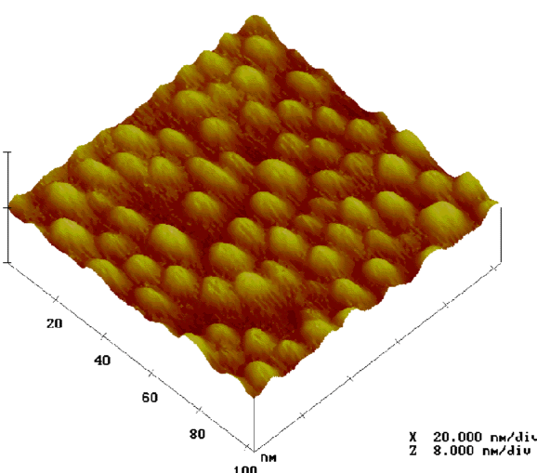

**Figure 3.3.4** Transmission electron microscopy image of the self-assembled QDs of GaN grown on AlN (from F. Widmann et al., MIJ-NSR, **2**, 20 (1997)).

1. Much more information on this subject can be found in Charles Kittel, *Introduction to Solid State Physics* (Wiley: New York, 1996) and Neil W. Ashcroft and N. David Mermin, *Solid State Physics* (Harcourt: Orlando, 1976).
2. i.e. the energy below which at zero temperature all the electronic states are occupied and above which all the states are empty.
3. In general, the effective mass is a tensor. It reduces to a scalar in crystals having a cubic symmetry.
4. In semiconductors, the Fermi level is situated in the gap. The width of this gap *E*g governs the optical absorption edge.
5. A cubic phase is somewhat more exotic. It is found for GaN, for example.
6. A. Kronenberger, P. Pringsheim, Z. Phys. **40**, 75 (1926).
7. I.V. Obreimov, W.J. de Haas, Proc. Acad. Sci. Amsterdam **31**, 353 (1928).
8. J. Frenkel, Physical Review **37**, 17 (1931).
9. Ya.I. Frenkel, Phys. Z. Soviet Union **9**, 158 (1936).
10. L. Apker and E. Taft, Physical Review, **79**, 964 (1950).
11. G.H. Wannier, Phys. Rev. 52, 191 (1937); N. F. Mott: Trans. Faraday Soc. **34**,500 (1938).