Quantum Entangled States in Coupled Quantum Dots (Shum)

Introduction
As the number of transistors on a computer chip – an indication of the chip’s computing power – ultimately approaches a new realm beyond Moore’s Law, quantum computers are being hailed as a new generation of computer, potentially able to do millions or billions of calculations simultaneously, unlike today's computers, which calculate sequentially. This astounding promise of quantum computing is based on the fact that each quantum bit (qubit) can be entangled with every other qubit in the quantum computer, so that a single manipulation affects them all.

Quantum entanglement is a quantum mechanical phenomenon in which the quantum state of two or more objects is described with reference to each other, even though the individual objects may be spatially separated. This leads to quantum correlations between observable physical properties of the systems. For example, it is possible to prepare two electrons in a single quantum state such that when one is observed to be spin-up, the other one will always be observed to be spin-down and vice versa. As a result, measurements performed on one object seem to be instantaneously influencing other object entangled with it.

Today’s high technologies ranging from optical communications to supercomputers are all based on the successful applications of quantum mechanics. The strong correlations associated with the phenomenon of quantum entanglement is now believed to form the basis for emerging technologies in quantum information theory such as quantum computing, quantum cryptography, quantum teleportation, and super-dense coding.

Problem Statement
Qubits are the basic building block for future quantum computers. It is not trivial to physically realize the hardware of qubits. It is even harder to probe, to control/gate, and to read out entangled qubits with high accuracy. Qubits should consist of at least two long-lived states, usually referred to as |0> and |1> of an object. The state of a single qubit should be also modified unconditionally or dependent on the setting of a second qubit.

Objectives
The objective of this research program is to theoretically characterize the eigenstates (a basis of any indeterminate state - qubits) of coupled quantum dots (CQD), as a solid state realization of qubit hardware, including various coupling mechanisms to find the sensitive signature of entangled qubits that can be experimentally generated, controlled, and read out.

Significance
This program acts as a bridge to guide, on one hand, material growers and device manufactures to grow and fabricate the theoretically well-defined CQD structures for qubit implementation, and on the other hand, to provide explanations of experimentally measured results.

Background
Recently, quantum entanglement has been observed [1] between an ideal quantum memory—represented by a single trapped Cd ion—and an ideal quantum communication carrier, provided by a single photon that is emitted spontaneously from the ion. Appropriate coincidence measurements between the quantum states of the photon polarization and the trapped ion memory were used to verify their entanglement directly.

The coupling of two quantum dots has been proposed as a means to generate entangled photons and to realize qubit gate operations [2, 3]. The search for qubit operations in solid state nanostructures, capable of large scale integration, other than individual atoms has triggered several studies of the coupling processes in QD ensembles [4] and individual CQD [5–8]. Quantum entanglement has not been directly verified in CQD structures.

I have had extensive research experiences on exciton, biexciton, triexciton in SiGe quantum dots [9, 10] and picosecond exciton dynamics in CdSe based quantum dots. [11]

Project Design
There are two approaches recently reported to characterize the eigenstates in CQD systems. Bester at al [12] used the atomistic pseudo-potential calculations for CQD with consideration of strain and alloy fluctuation, while Zhu at al [13] provided a variation diagonalization approach to efficiently characterize the excitonic states under the framework of the effective mass approximation. The degree of quantum entanglement is described by the von Neumann’s entropy [14]

S = − Tr [ρA log2 ρA], Eq. (1)

Where ρA is density operator of the subsystem A which is quantum mechanically entangled with the subsystem B. For the maximally entangled subsystem A with B, the von Neumann’s entropy is equal to 1.

We will apply both of these two known approaches [12, 13] wherever suitable and the well-defined Eq.(1) to calculate the following three major sets of data for any given CQD structures such as vertically or horizontally coupled two-dot system:
- Set A:
General eigen-states (eigen-energies and eigen-wave-functions) and its variation of general states under small perturbation of material, structure, and bias parameters
- Set B:
The strength of coupling (see below for the cause of coupling) with nominal material, structure, and bias parameters and its variation of coupling under small perturbation of material parameters
- Set C
The von Neumann’s entropy for the entangled states and find the experimentally observable signatures
We will theoretically investigate the following coupling mechanisms between QDs:
- electron and/or hole tunneling,
- dipole-dipole interaction of excitons [biexciton],
- photon addressed electron/hole and exciton molecule [Forster interaction], and
- phonon addressed electron/hole and molecule

The detailed material, structure, and bias parameters are described in the following table:
Material | Potential barrier heights  Strain  Alloy fluctuation  Residual doping
Structure | Inter-dot separation  Dot geometry
Bias | Electrical field
Preliminary Results
We have carried out a preliminary study of an electron-hole two-body system in CdSe based CQD system with various thickness of barrier width. The calculated results are shown in Fig. 1 to 4.

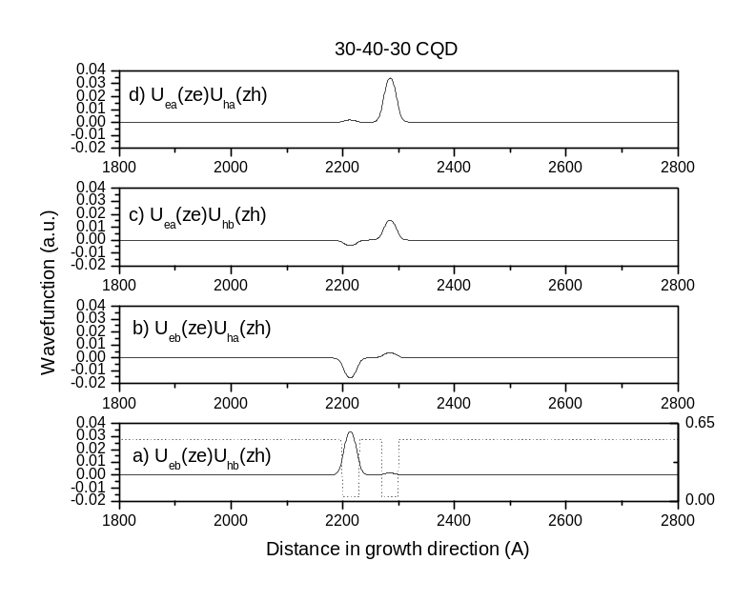

Fig. 1 Four combinations of electron- and hole-molecular orbits for CdSe based 30-40-30 (in angstrom) well-barrier-well width CQD (same notation will be used below).

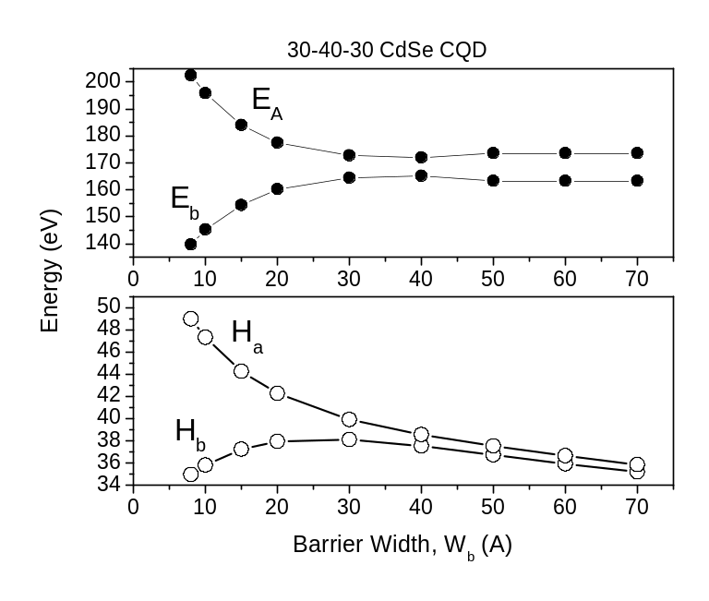
Fig. 2 Eigen-energies for four e/h molecular orbits are calculated as function barrier width.

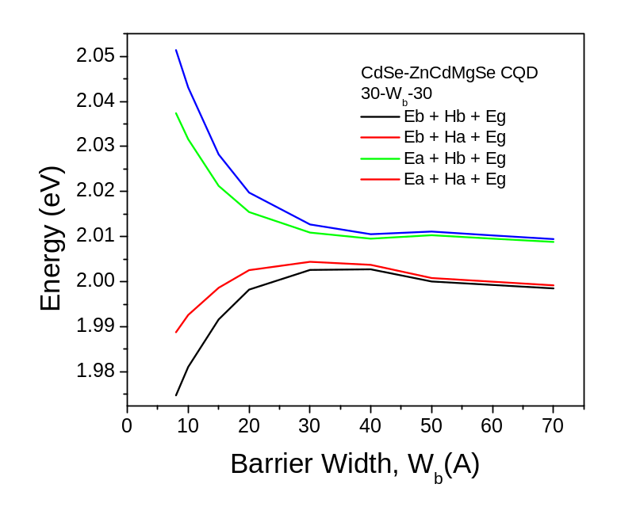
Fig. 3 Four possible e-h recombination energies are shown as a function barrier width.
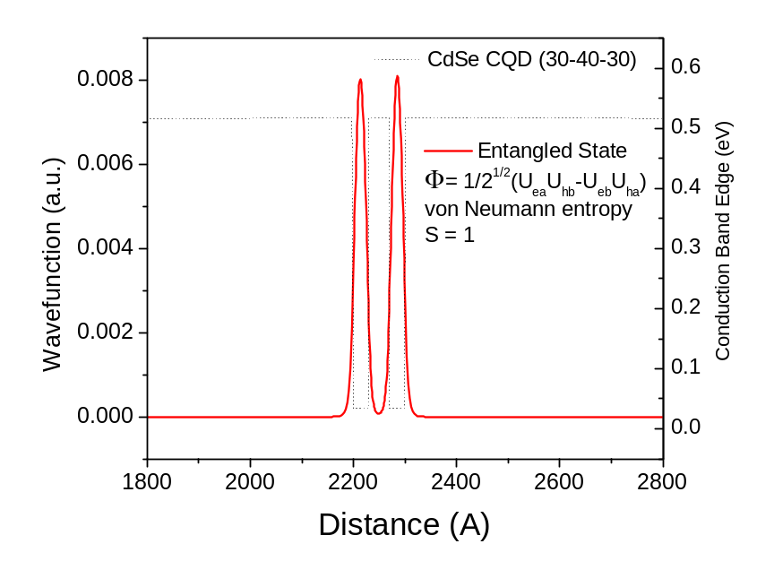
Fig. 4 A constructed entangled qubit of a composite system with an electron and a hole as subsystems.

References

- “Observation of entanglement between a single trapped atom and a single photon”, B. B. Blinov, D. L. Moehring, L.- M. Duan & C. Monroe, Nature 428 (153) 2004.
- G. Burkard, D. Loss, and D. P. DiVincenzo, Phys. Rev. B59, 2070 (1999); T. Calarco, A. Datta, P. Fedichev, E. Pazy, and P. Zoller, Phys. Rev. A 68, 012310 (2003); O. Gywat, G. Burkard, and D. Loss, Phys. Rev. B 65, 205329 (2002).
- B.W. Lovett, J. H. Reina, A. Nazir, and G. A. D. Briggs, Phys. Rev. B 68, 205319 (2003).
- C. R. Kagan, C. B. Murray, and M. G. Bawendi, Phys. Rev. B 54, 8633 (1996); M. Ouyang and D. D. Awschalom, Science 301, 1074 (2003); S. A. Crooker, J. A. Hollingsworth, S. Tretiak, and V. I. Klimov, Phys. Rev. Lett. 89, 186802 (2002).
- G. Schedelbeck, W. Wegscheider, M. Bichler, and G. Abstreiter, Science 278, 1792 (1997); I. Shtrichman, C. Metzner, B.D. Gerardot, W.V. Schoenfeld, and P. M. Petroff, Phys. Rev. B 65, 081303 (2002).
- M. Bayer et al., Science 291, 451 (2001).
- G. Ortner et al., Phys. Rev. B 71, 125335 (2005).
- H. J. Krenner et al., Phys. Rev. Lett. 94, 057402 (2005).
- "Quantum indistinguishability effects of confined polyexcitons", Kai Shum, P. M. Mooney, and J. O. Chu, Phys. Rev. B 60, 5786 (1999).
- "Quantum confined biexcitons in SiGe grown on Si(001)", Kai Shum, P. M. Mooney, L. P. Tilly, and J. O. Chu, Phys. Rev. B 55, 13058 (1997).
- "Observation of 1P excitonic state in Cd(S,Se) quantum dots", Kai Shum, W. Wang, R. R. Alfano, and K. M. Jones, Phys. Rev. Lett. 68, 3904 (1992).
- G. Bester, and A. Zunger, Phys. Rev. B 72, 165334 (2005).
- J. Zhu, W. Chu, Z. Dai, and D. Xu, Phys. Rev. B 72, 165346 (2005).
- C. H. Bennett, H. J. Bernstein, S. Popescu, and B. Schumacher, Phys. Rev. A 53, 2046 (1996)

