Prof Rudowsky CISC3810 HW3
- Using the STUDENT and PROFESSOR tables shown in Figure Q3.8 to illustrate the difference between a natural join, an equijoin, and an outer join (full, left and right)

FIGURE Q3.8 The Ch03_CollegeQue Database Tables
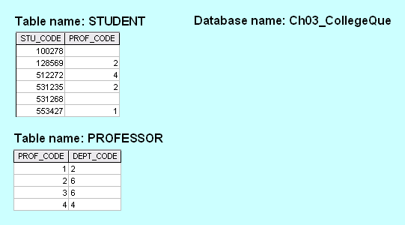

Figure Q3.11 The Ch03_VendingCo database tables

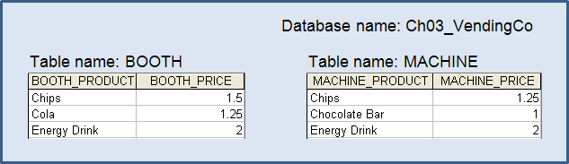

11. Create the table that results from applying a UNION relational operator to the tables shown in Fig Q3.11

- Create the table that results from applying an INTERSECT relational operator to the tables shown in Fig Q3.11.

- Using the tables in Figure Q3.11, create the table that results from MACHINE DIFFERENCE BOOTH.
- Suppose that you have the ERM shown in Figure Q3.14.

FIGURE Q3.14 The Crow’s Foot ERD for Question 14
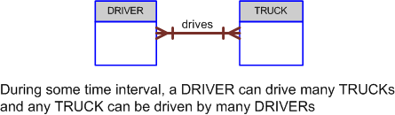

How would you convert this model into an ERM that displays only 1:M relationships? (Make sure that you draw the revised ERM.)

Use the database composed of the two tables shown in Figure Q3.18 to answer Questions 18-23.

FIGURE Q3.18 The Ch03_Theater Database Tables
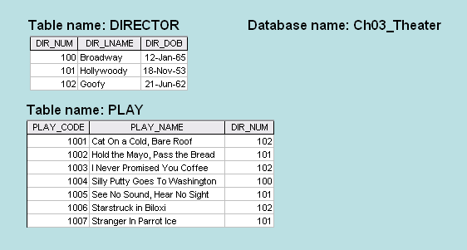

- Identify the primary keys.

DIR_NUM is the DIRECTOR table's primary key.
PLAY_CODE is the PLAY table's primary key.

- Identify the foreign keys.

- Suppose you wanted quick lookup capability to get a listing of all plays directed by a given director. Which table would be the basis for the INDEX table, and what would be the index key?

The PLAY table would be the basis for the appropriate index table. The index key would be the attribute DIR_NUM.

- What would be the conceptual view of the INDEX table that is described in question 22? Depict the contents of the conceptual INDEX table.

The conceptual index table is shown in Table Q3.23.

Figure Q3.23 The Conceptual Index Table
Index Key | Pointers to the PLAY table
100 | 4
101 | 2, 5, 7
102 | 1, 3, 6

