1. **Given the dependency diagram shown in Figure Q6.6, answer items 6a-6c:**

**FIGURE Q5.6 Dependency Diagram for Question 6**



* 1. **Identify and discuss each of the indicated dependencies.**
  2. **Create a database whose tables are at least in 2NF, showing the dependency diagrams for each table.**
  3. **Create a database whose tables are at least in 3NF, showing the dependency diagrams for each table.**

1. **The dependency diagram in Figure Q6.7 indicates that authors are paid royalties for each book that they write for a publisher. The amount of the royalty can vary by author, by book, and by edition of the book.**

**Figure Q6.7 Book royalty dependency diagram**

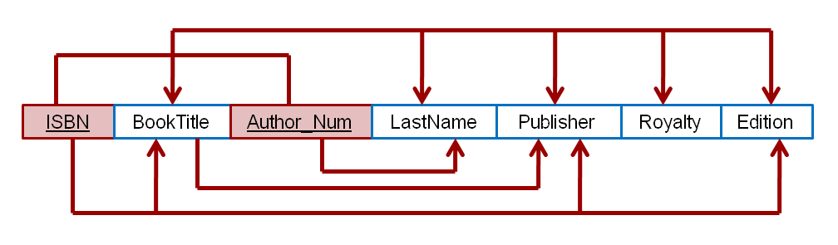

1. **Based on the dependency diagram, create a database whose tables are at least in 2NF, showing the dependency diagram for each table.**
2. **Create a database whose tables are at least in 3NF, showing the dependency diagram for each table**
3. **The dependency diagram in Figure Q6.8 indicates that a patient can receive many prescriptions for one or more medicines over time. Based on the dependency diagram, create a database whose tables are in at least 2NF, showing the dependency diagram for each table.**

**Figure Q6.8 Prescription dependency diagram**

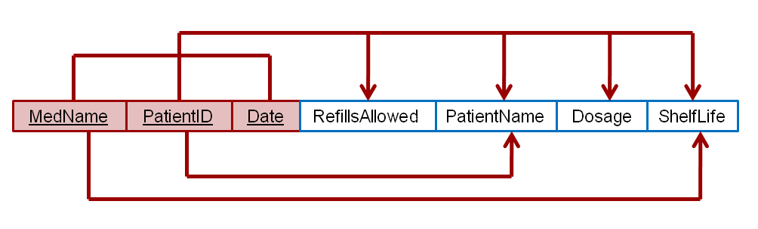

* + 1. **Using the descriptions of the attributes given in the figure, convert the ERD shown in Figure P6.1 into a dependency diagram that is in at least 3NF.**

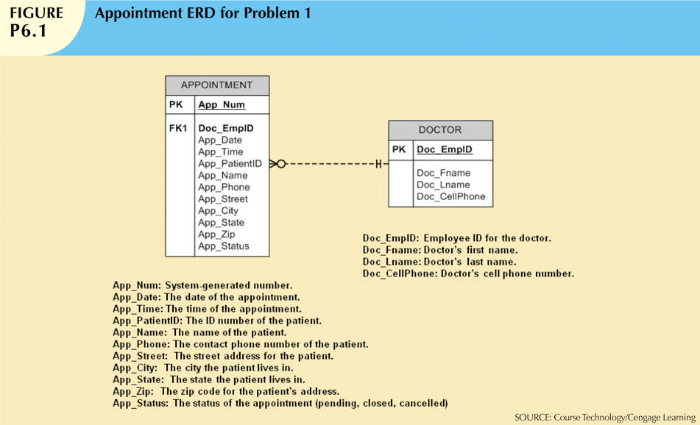

1. **Using the INVOICE table structure shown in Table P6.3, do the following:**

**Table P6.3 Sample INVOICE Records**

|  |  |  |  |  |  |
| --- | --- | --- | --- | --- | --- |
| **Attribute Name** | **Sample Value** | **Sample Value** | **Sample Value** | **Sample Value** | **Sample Value** |
| INV_NUM | 211347 | 211347 | 211347 | 211348 | 211349 |
| PROD_NUM | AA-E3422QW | QD-300932X | RU-995748G | AA-E3422QW | GH-778345P |
| SALE_DATE | 15-Jan-2010 | 15-Jan-2010 | 15-Jan-2010 | 15-Jan-2010 | 16-Jan-2010 |
| PROD_LABEL | Rotary sander | 0.25-in. drill bit | Band saw | Rotary sander | Power drill |
| VEND_CODE | 211 | 211 | 309 | 211 | 157 |
| VEND_NAME | NeverFail, Inc. | NeverFail, Inc. | BeGood, Inc. | NeverFail, Inc. | ToughGo, Inc. |
| QUANT_SOLD | 1 | 8 | 1 | 2 | 1 |
| PROD_PRICE | $49.95 | $3.45 | $39.99 | $49.95 | $87.75 |

1. **Write the relational schema, draw its dependency diagram and identify all dependencies, including all partial and transitive dependencies. You can assume that the table does not contain repeating groups and that any invoice number may reference more than one product. (*Hint*: This table uses a composite primary key.**
2. **Remove all partial dependencies, draw the new dependency diagrams, and identify the normal forms for each table structure you created. You can assume that any given product is supplied by a single vendor but a vendor can supply many products.**
3. **Remove all transitive dependencies, and draw the new dependency diagrams. Also identify the normal forms for each table structure you created.**