CORC 1312 Review Sheet Exam 2 Prof Rudowsky

Javascript
- prompt
- alert
- parseInt, parseFloat
- document.write
- document.location
- document.bgColor, fgColor, linkColor, vLinkColor
- document.getElementById(‘xyz’).value or .src (see examples below)
- window.open(); – opens a blank web page
- windows.open(http://www.cnn.com); opens a web page displaying cnn.com
- text box for input, text box for output - using getElementById
- button with onclick
- img tag using onmouseout, onmouseover and onclick

CPU simulators –
- Function of the control unit
- I will give you a snapshot of a simulator and ask you how the knobs and gates should be set to perform a particular operation (see below)

Code for text boxes, buttons, images. Copy the code into an HTML file and display it in a browser to study how each part works
- Textbox and two buttons – enter a number into the textbox, push button to add 5 or subtract 5, results put back into same textbox using getElementById
- Image initially appears as happy face, put cursor on the image changes to sad face, move cursor off changes back to happy face by using onmouseover and onmouseout
- Image starts out as happy face, you have two buttons – one to make the face happy and one to show the face as sad by using onclick

<html> <body>
<!—Example 1-->
Enter a number <input type="text" id="number" size="10">
<input type="button" value="Add 5 to number"
onclick="num=parseInt(document.getElementById('number').value);
document.getElementById('number').value = num+5";>
<input type="button" value="Subtract 5 from number"
onclick="num=parseInt(document.getElementById('number').value);
document.getElementById('number').value = num-5";>
<P>
<!—Example 2-->
<img src="happy.gif" onmouseover="this.src='sad.gif';"
onmouseout="this.src='happy.gif';">
<p>
<!—Example 3-->
<img src="happy.gif" id ="pic">
<input type="button" value="Be Happy" onclick="document.getElementById('pic').src='happy.gif'";>
<input type="button" value="Be Sad" onclick="document.getElementById('pic').src='sad.gif'";>
</body> </html>

Know the basic assembly language instructions so that you can determine what a program does when given input (such as the last question on the homework assignment)

LOAD RR MMMMM – load from memory into a register
SUB RR RR RR – subtract the rightmost
ADD RR RR RR
STORE MMMMM RR – store from a register into memory
HALT

Simulator Example 1: (a) How should the A bus, B bus, C bus and ALU knobs be set to add the contents of R0 and R1 and put the result into R3

(b) How should the A bus, B bus, C bus and ALU knobs be set to double the value stored in R0 and put the result back into R0
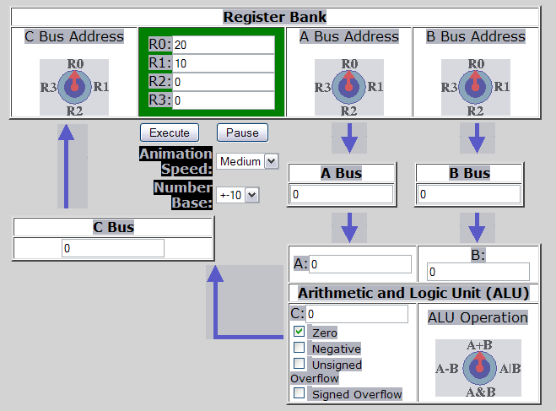

Example 3: If a setting doesn’t matter, enter N/A
- What settings are needed to put the value in memory location 0 into R0
A bus knob | B bus knob | ALU knob | C bus knob | ALU gate | MMB1 gate | MMB2 gate | C bus gate | RW button

- What settings are needed to put the contents of R2 into Memory location 3

A bus knob | B bus knob | ALU knob | C bus knob | ALU gate | MMB1 gate | MMB2 gate | C bus gate | RW button

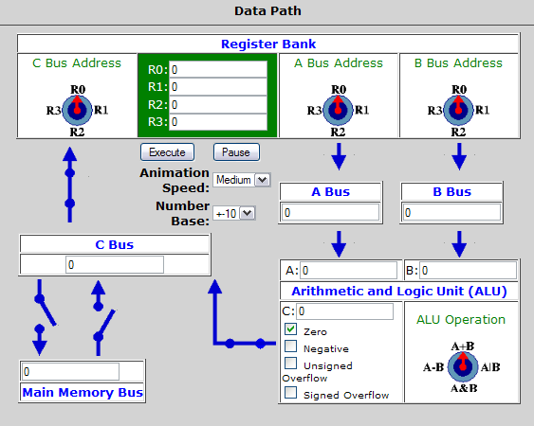
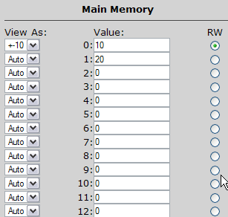
MMB1
MMB2

