Recognizing Stereoisomers

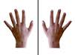

Generally we use the 2^{n} rule to determine the number of stereoisomers in a compound, with “n” being the number of chiral centers. However, this rule is not full proof. There are certain symmetry elements that can appear in a molecule which will cause the molecule to actually have less than “2^{n} ” stereoisomers. For example, the 2^{n} rule does not take into account that meso compounds have no enantiomer (mirror image) and that therefore for every meso compound, 1 needs to be subtracted from the total number of stereoisomers. Remember that meso compounds have some kind of symmetry and therefore their mirror image will in fact be identical, rather than a separate stereoisomer.

INSTRUCTIONS

Follow the directions below and try to answer each question yourself before scrolling down to see the answer. Have a pen and paper ready to write down your answers as you go along.

INTRODUCTORY PROBLEM

Let’s first look at a compound with two stereocenters: 2,3-dichlorobutane.
Please draw out 2, 3-dichlorobutane without specifying stereochemistry and then move on to the next page.

This is a picture of 2,3-dichlorobutane:

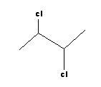

How many stereoisomers do you anticipate for this compound?
(Hint on the bottom of the page)

(hint= 2^{n} rule- 2 raised to the power of the number of chiral centers)

We anticipate that there will be 4 stereoisomers, because 2² = 4
Carbons 2 and 3 are chiral centers.

Draw out the first stereoisomer by using the dash/wedge notation to draw the 2R, 3R isomer:

When you have drawn out (2R,3R) 2,3-dichlorobutane, move onto the next page.

Our first stereoisomer is 2R,3R:

1)
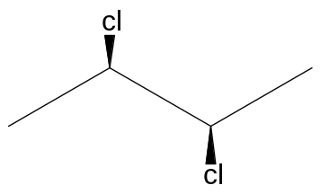

Is this molecule chiral?
(Scroll down for the answer)

Yes. It’s chiral.

Does it have an enantiomer?
(Scroll down for the answer)

Yes. It has an enantiomer. The enantiomer will have the opposite stereochemistry which will be________________________________.
(Scroll down for the answer)

(2S, 3S) 2, 3-dichlorobutane

Draw out (2S, 3S) 2, 3-dichlorobutane using wedge/dash notation

2) Our second stereoisomer is (2S, 3S) 2,3-dichlorobutane:

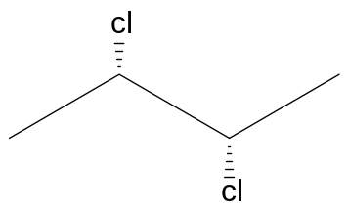

Is this molecule chiral?
(Scroll down for answer)

Yes. It’s chiral. And it is the enantiomer of 2R, 3R.

Now draw out a 2R, 3S using dash/wedge notation:

Here is the 2R,3S isomer:

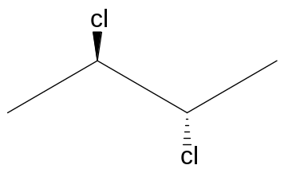

Is this molecule chiral?
(scroll down for the answer)

No. It is not chiral. It is a meso compound because it has 2 chiral centers with the same groups attached to it, yet, each center has opposite stereochemical configuration. It is easy to see that this compound has a plane of symmetry by drawing it out in a Fischer projection:

Fill in the Fischer projection of the meso compound, and draw a line of symmetry through it.

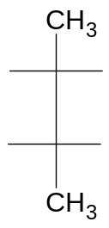

The filled in Newman projection is shown here with the correct line of symmetry:

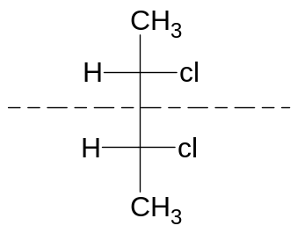

Because this is a meso compound it is achiral and does not have an enantiomer; therefore there are a total of only 3 stereoisomers for 2,3 dichlorbutane, as opposed to the 4 that we had anticipated using the 2^{n} rule.

CHALLENGE PROBLEM #1

Now let’s move onto a more challenging problem.
Given this compound:
3,4-dichlorocyclopentanoic acid

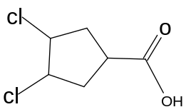

Let us try to determine how many stereoisomers we can find for this compound. The first thing we need to do, is determine how many stereocenters we have.
How many are there?
(scroll down for the answer)

There are actually only 2 true chiral centers. Each carbon attached to a chlorine is a chiral center. The ring carbon attached to the carboxylic acid and a hydrogen, has 2 equal paths in either direction which makes it a “pseudochiral center” and not a true one.

Take a deeper look at the carbon attached to the carboxylic acid. It appears as if the ”C=O” and the “OH” group are both in the plane of the paper, however, they are not. For a moment, let’s ignore the chlorine groups and look at the ring with just a carboxylic acid attached.

We will look at a few views of the molecule to get a clear idea of how it looks in three dimensions.

Here is a view of the molecule from the top:

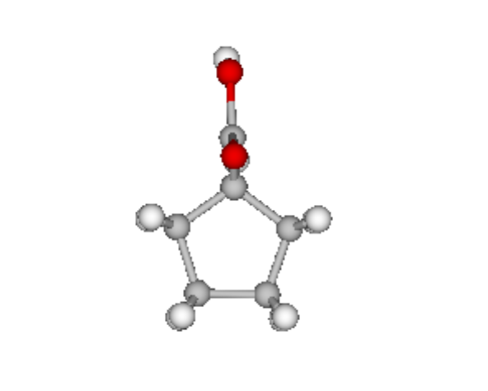
Notice the hydrogens that are eclipsed and the carboxylic acid group points towards us.

We can draw the following plane of symmetry through this molecule:

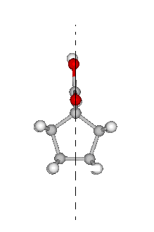

It is extremely important to keep this in mind in order to determine the correct amount of stereoisomers. Regardless of if the carboxylic acid group is pointing towards or away from us, the “C=O” and the “OH” group are in line with each other.

For convenience sake we will draw the ”C=O” and the “OH” group next to each other as follows:

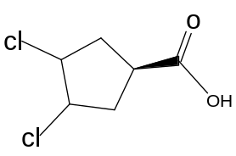

Now let’s solve the problem:

First, draw a stereoisomer with all three groups facing us:
Use wedge/dash notation
(scroll down to see the answer)

1)
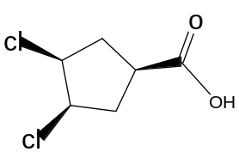

Is this molecule chiral?
(scroll down to see the answer)

No. It is not. It is a meso compound because it contains a plane of symmetry.
Can you draw the plane of symmetry on the molecule below?
(hint: remember that the carboxylic acid C=O and OH are in line with each other)

The drawing above really looks like the one below

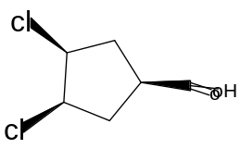
Where the ”C=O” and the “OH” are in line with each other.

The plane of symmetry is through the carboxylic acid, and between the 2 chlorines:

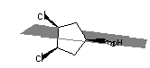

If we were to divide the molecule into 2 pieces, we would get two equal parts!!
Looking at the above structure, can you think of any other stereoisomer that would have a similar plane of symmetry? (Use wedge/dash notation)
(See below for hint)

(think about moving the carboxylic acid in the other direction, to give another meso compound)

Another meso compound would keep the chlorines in the same direction, and put the carboxylic acid in the opposite direction.

2)

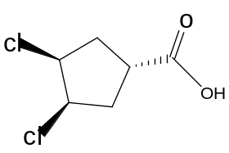

The plane of symmetry for this molecule would be the same as for stereoisomer #1, except that the carboxylic acid is pointing away from us.

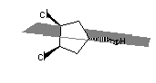

If we divided the molecule along the plane of symmetry we would get two equal pieces.

It is important to note, that because the first 2 stereoismers we have drawn are meso compounds, they have no enantiomers.

Now, try to come up with another stereoisomer. Draw it using the dash/wedge notation. (Scroll down for a hint)

Hint: try putting the chlorines in different directions.

Note: One possible answer

3)
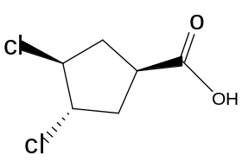

Is this molecule chiral?
(scroll down for answer)

Yes. It is chiral. Can you draw its enantiomer?

3) 4)

Its mirror image looks like #4: 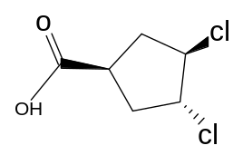

Another way to draw #4) is like shown below, with opposite configuration of #3). It is the same as thing, just rotated

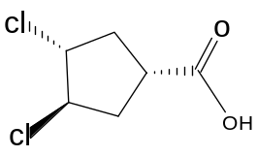

Are there any more stereoisomers of this compound?
(scroll down for answer)

No. There are only 4 stereoisomers. If you attempted to draw #3 with the carboxylic acid on a dash, you would actually get the same compound as #3, only rotated 180 degrees downward:

Rotate #3
To get

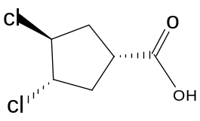

It’s the same molecule!!! Not another stereoisomer!

The same is true if we change the configuration of the carboxylic acid on stereoisomer #4. It will be stereoisomer #4, rotated 180 degrees.

For this molecule there are a total of 4 stereoisomers.

Challenge Problem #2

Now let’s proceed to a more challenging problem. Take a look at this molecule:

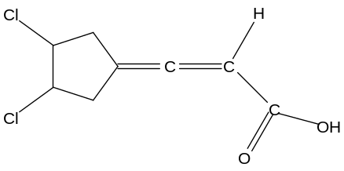

We cannot proceed to determine how many stereoisomers this has without a discussion of orbitals. We will leave off the chlorine groups for now. In the previous example the carbon of the carboxylic acid was coming off the ring in a different plane; that is, it was either facing towards us or away from us because the carbon that it was attached to, was sp³ and therefore, the geometry around it was tetrahedral. Here, however, the carbon with the double bond coming off the ring, has a hybridization of sp² and it is therefore, planar. That means that the double bond “C” is flat and will not be drawn on a dash or a wedge.

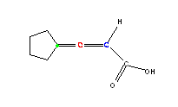

The green dot represents the carbon that is sp², the red carbon is sp, and it is linear, so the blue “c” is also in the plane of the page, and the blue “c” is sp². However, the groups that the blue “c” is attached to are not in the plane of the page, like they appear to be.

Take a look at the orbital diagram:
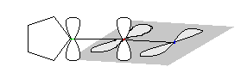

The nonshaded orbitals are facing up-down and are in the plane of the page, and the shaded in orbitals are facing towards us in a different plane. The orbitals overlap on top and on bottom for the nonshaded, and in front and back for the shaded ones. The implication of this is that whatever is attached to the blue carbon will be in a different plane and will be facing towards us and away from us. Look at how the red atoms representing the double bond “O” and the “OH” group are in a different plane than the ring and are actually facing us or away from us.

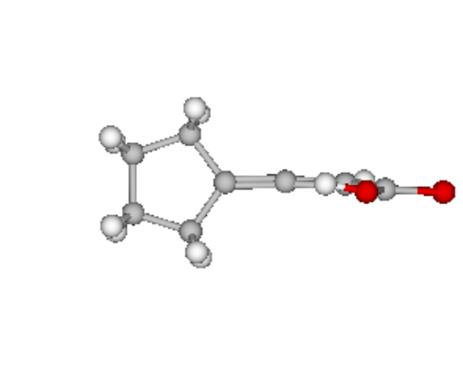
Notice the eclipsing hydrogens in the ring and the carboxylic acid that is in a different plane than the ring.

Now that we understand how the molecule looks in three dimensions, we can start to determine how many stereoisomers it has. Let’s draw the original molecule in 2 dimensions and try to determine the number of stereoisomers.

Remember: even though we are drawing it like this for convenience sake, the carboxylic acid is actually out of the plane of the paper with the “O” and the “OH” in line with each other. (look back at the 3-D drawings)

We can take what we’ve already done in the previous example and apply it to this example because they are almost identical, even though it did not seem that way at first glance.

First, draw a stereoisomer with all the groups facing towards us.(be careful to put the dash/wedge in the appropriate place.

(scroll down for answer)
1)
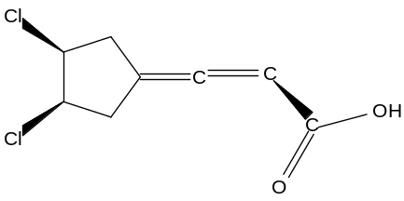
Here all the groups are facing towards us.
Does this compound have a plane of symmetry? Does it have an enantiomer?
(scroll down for answer?)

This compound is a meso compound and does have a plane of symmetry. It therefore has no enantiomer. Can you draw the plane of symmetry?

Remember that the molecule doesn’t look like this; it looks like
(The top groups appear to be blocking some of the carbons underneath):

The plane of symmetry is right down the middle, bisecting the double bond “O” and “OH” as well as the double bond “C’s”.

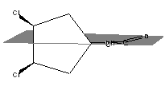

Cutting it down the middle would give two identical parts and so, it is a meso compound. Can you come up with another meso compound?

(Hint: look back at the previous example)

2) Put the carboxylic facing away from us

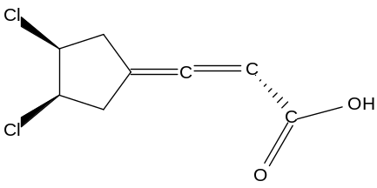

The plane of symmetry will be the same for this one, except, the carboxy group will be facing away.

Can you think of another stereoisomer?

(try putting the chlorines in different directions)

3)
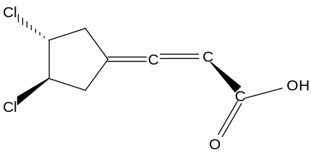

Is this molecule chiral? (scroll down for answer)

Yes it is. Can you draw its enantiomer?

Here is #3 with its mirror image:

4)
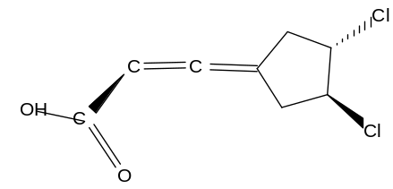

Another way to draw #4 is with opposite configuration like this:

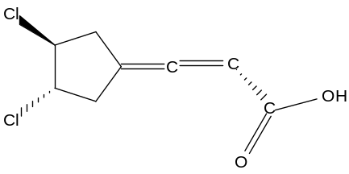

Can you think of anymore stereoisomers?

No. If you came up with anymore they are a rotation of one of the 4 stereoisomers already listed. For example, if you took the #4 stereoisomer, and made the carboxylic acid group on a dash, you would actually be getting the same stereoisomer, rotated 180 degrees downward:

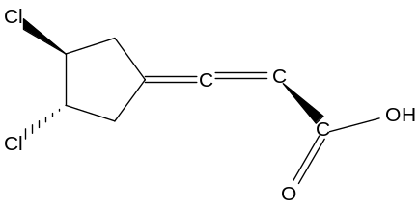

rotate 180 degrees to get :

4)

They are actually the same!!!!!!!!!!!!!!

Challenge Problem #3

Now let’s proceed to a different kind of challenging problem. The difficulty with determining stereoisomers is sometimes trying to figure out if two things are really the same, even though they may look different when they are oriented differently.

Truxinic acid is four membered ring with two adjacent carboxyl groups and two adjacent phenyl groups:

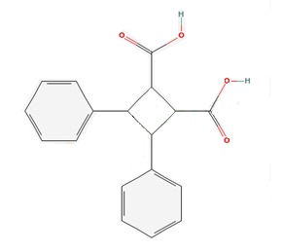

How many stereoisomers do you anticipate truxinic acid will have?
(Scroll down for the answer)

Truxinic acid has 4 chiral centers and so we anticipate having 16 stereoisomers (2⁴ ), but we have to be careful to subtract from that number, if we come up with any meso compounds, or identical pairs.
To simplify things we will write “acid” and “ph” to represent the functional groups.

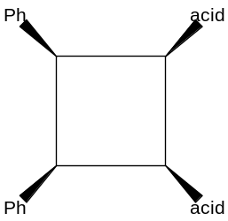

It is a good idea to also make little 3-dimensional drawings to visualize the different stereoisomers. Here we will represent the phenyl groups with filled in circles and the carboxylic acid groups with empty circles.
i.e.:
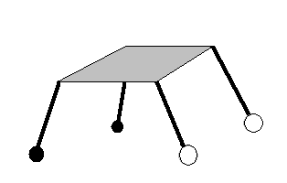

Think about the groups with wedges as the legs of this “table”, and the ones with dashes as above the top of the table. Specifying R and S configuration will help you keep track of which stereoisomers you have drawn already.

How many stereoisomers, does truxinic acid actually have?
Let’s start by putting all the groups facing towards us.
Fill out the template below using wedge/dash notation, and the little 3-d drawing to help you.
Remember that the phenyls are adjacent and the carboxylic acids are adjacent.

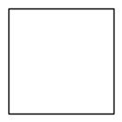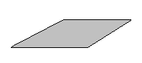

1)
Or

Is this compound chiral?
(Scroll down for the answer)

No. It is not chiral. It has a plane of symmetry. Can you draw the plane of symmetry through the compound? Can you draw the enantiomer of this compound?

This is a meso compound because it has a plane of symmetry:

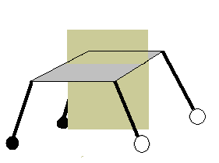

Here’s a view of the plane of symmetry from the side:

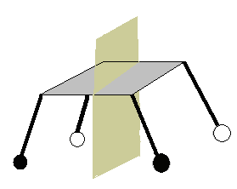

Therefore, there is no enantiomer.

Can you think of a way to draw another meso compound?
(Hint below)

(hint: try putting the pairs facing opposite directions)

2)
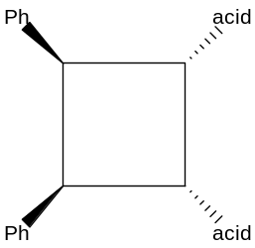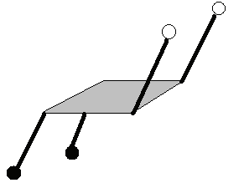

Does this have a plane of symmetry?
(scroll down for answer)

Yes. It does. Can you draw it?

The plane of symmetry is as shown. Therefore this is a meso compound and doesn’t have an enantiomer.

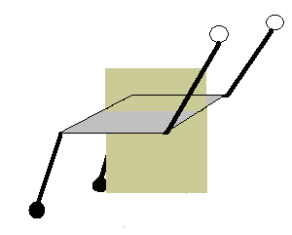

Can you draw another stereoisomer with one acid facing away?

3)
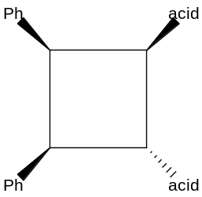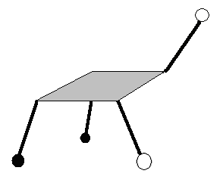

Is this molecule chiral?
(scroll down for answer)

Yes. It is chiral. Can you draw its enantiomer?
4)

4)
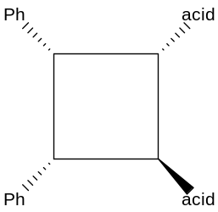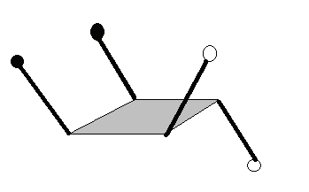

Rotate 180 degrees

Let’s rotate the enantiomer to show that they are mirror images
3) 4)
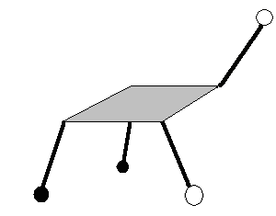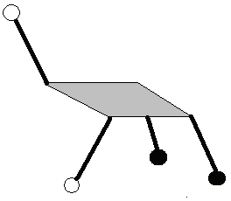

Here’s a tough question: If we drew the same molecule, but instead put the other carboxyl group facing away, would we get a different molecule? Let’s draw it and compare: We will call it X***

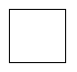

X***)

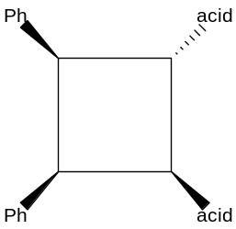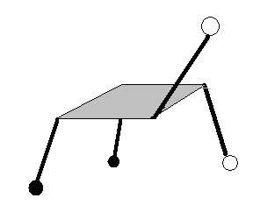

Lets compare this to stereoisomer #3
-------------------------------------

3)

Look how they are mirror images, over the dotted line. Let’s rotate to clarify

X*** 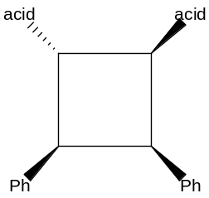 3) 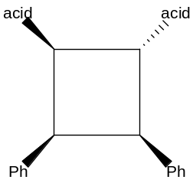

Notice that this is actually the enantiomer of #3 in a different orientation!!!!!!!!!
That means X*** is actually #4!!!! This means that the enantiomer of X*** will be stereoisomer #3!

What can we draw for our next stereoisomer, that will separate the phenyl groups?
(scroll down for answer)

Draw a stereoisomer with one of the phenyl groups facing away from us:

5)

5)
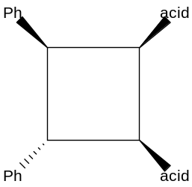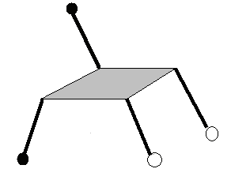

Is this molecule chiral?
(Scroll down for answer)

Yes. It is chiral. Can you draw its enantiomer?

6)
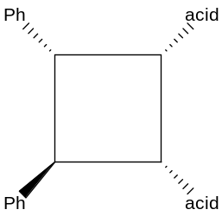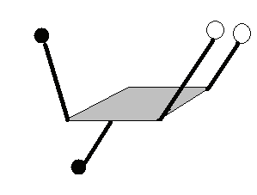

Rotate 180 degrees
5)
6)
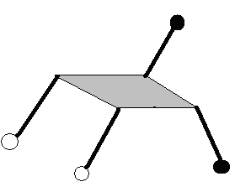

Draw the molecule, except this time put the other phenyl group away from us;

Is this a different stereoisomer from any we have done so far?

No. It is a repeat. Let’s look at it and see. We will call this Y***

Y***)

Compare this to #5: notice how they are mirror images!!!!!!!!

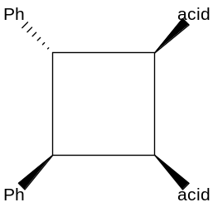

----------------------------------------
5)

Let’s rotate it to clarify

5) Y***)
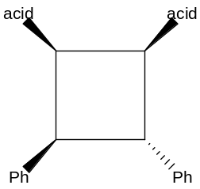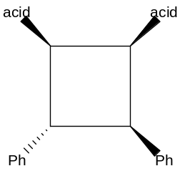

Notice that Y** is actually the enantiomer of #5 in a different orientation!!!!!!!!!
That means Y*** is actually #6!!!! This means that the enantiomer of Y*** will be stereoisomer #5!!!

Can you think of any more stereoisomers to draw?
(Scroll down)

Yes! Draw the stereoisomer with opposite groups facing the same way:

7)
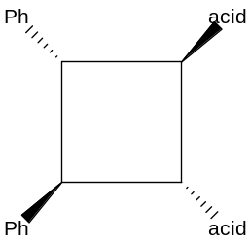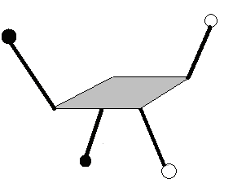

Is this molecule chiral?
(Scroll down for answer)

Yes! Can you draw its enantiomer?

8)

8)

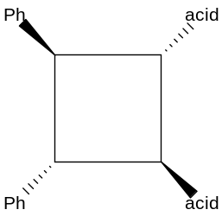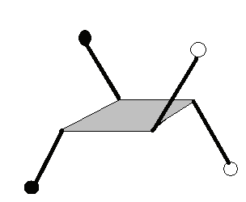

Rotate 180 Degrees

Numbers 7 and 8 are mirror images!

7) 8)
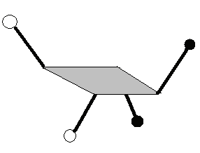

Can you draw any more stereoisomers?
(scroll down)

Yes!! Draw adjacent, nonidentical groups facing the same direction:
9)

9)

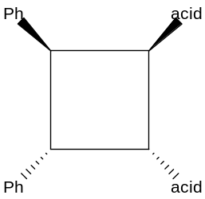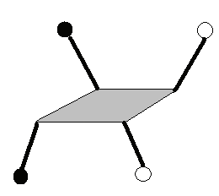

Is this molecule chiral?

Yes! Can you draw its enantiomer?

10)
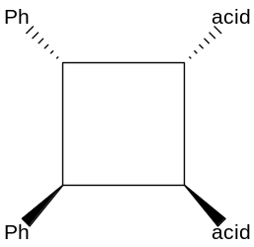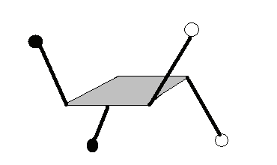

Rotate 180 Degrees

Numbers 9 and 10 are mirror images!!!

9) 10)
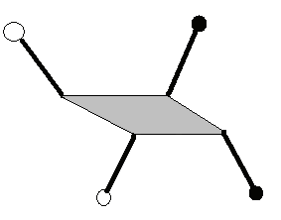

Can you think of any more stereoisomers? If you can, you are most like drawing something flipped over backwards. We have a total of 10 stereoisomers, which is not consistent with the 2^{n} rule. There were some symmetry elements that were not accounted for and so we came up with less than 16.

