Models with Trends and Nonstationary Time Series

Ref : Enders Chapter 4, Favero Chapter 2, Cochrane Chapter 10.

The general solution to a stochastic linear difference equation has three parts:

The noise component: ARCH, GARCH approaches model this variance (volatility) component.

The stationary component: AR(p), MA(q), ARMA(p,q) models. Require the roots of the characteristic equation to lie within the unit circle (or the roots of the inverse of the characteristic equation to lie outside the unit circle).

Here: we examine the trend component.

Trend = deterministic trend + stochastic trend

Deterministic trend: constant, accelerating nonrandom trend.
Stochastic trend: random. It can be due to any shock, such as technology, oil prices, policy, etc.

Until the 1960s researches modeled time series as covariance stationary.
Problem: this assumption did not describe macroeconomic time series that generally grow over time.

Originally some proposed ways for dealing with the problems of growing series:
- taking the log of Y and
- assuming the DGP could be described by 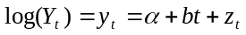, where y was assumed covariance stationary and E(y)=0, which led to expected growth rate of b in the series: 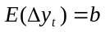. The series y were said to be trend stationary.

Box and Jenkins first proposed the idea that instead of treating the macro series as covariance stationary around a deterministic trend, we should accept that they are not cov stationary, but instead first difference them to make them cov stationary:
If 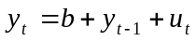, then a stationary model for y would be: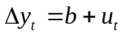. They then modeled u as a covariance stationary, ARMA (p,q) process and thus y is an ARIMA(p,1,q) process.

Reminder: “I” stands for integrated process and “1” shows that the process needs to be differenced once to be stationary: integrated of degree 1=I(1). A covariance stationary series are I(0). If a time series needs to be differenced d times to become stationary, it is integrated of degree d, I(d).
Then the series can be represented by an integrated moving average process of the order, p, d, q, an ARIMA(p,d,q). Usually d=1 is sufficient. In economics d=2 is the maximum we would need to differentiate. For ex: rate of growth of inflation (differentiate the price level twice).

They showed that many time series could be successfully modeled this way. Nelson and Plosser (1982) later tested and confirmed that they could not reject nonstationarity in most macroeconomic and financial series. They suggested technology shocks as an explanation for this finding, but others later interpreted it as evidence of rigidities. Since this finding, which established that most macroeconomic and financial series can be described well by an ARIMA process, nonstationarity became part of macroeconometrics.

Why is it important to recognize this?
Most macro variables are very persistent (nonstationary). But standard inference techniques are unreliable with nonstationary data.
Dickey and Fuller: OLS estimates are biased towards stationarity, suggesting that series that looked stationary with OLS regressions would be in fact generated by random walks. This finding made most of the conclusions in the macro literature wrong or at least undependable.

In this lesson, we will look at:
- Trend stationary models
- Random walk models
- Stochastic trend models
- Trends and univariate decompositions

When a process is unit root nonstationary, it has a stochastic trend. If linear combinations of more than one nonstationary processes do not have stochastic trends, these variables are cointegrated.

I. Trend Stationary and Difference Stationary Models
Consider the process
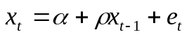
where e is white noise (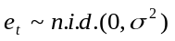).

If 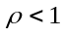 we can write
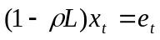 hence 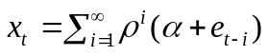 stationary process.

If 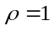, then 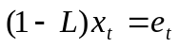, there is a unit root in the AR part of the series and we have to solve the equation recursively. If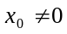, recursive substitution until t=0 gives the solution:
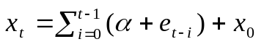.

Rewriting:

(2) 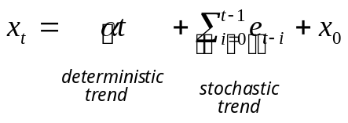.
If there are no shocks, the intercept is 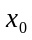.
Suppose there is a shock at time i (e.g. an oil-price shock), it shifts the intercept by 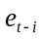 and the effect is permanent (with coefficient 1). This is a stochastic trend since each shock affects the mean randomly. The model has a very different behavior than the traditional covariance stationary models where the effect of shocks dies over time.

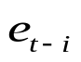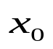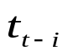
GDP
time

If 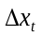~I(0) then
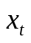

Trend Stationary (TS) Difference Stationary (DS)
has a linear time trend I(1) or unit root stationary
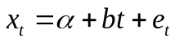 LR 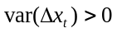
LR 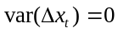 Non-zero serial correlation.
Special case: random walk

Look at special cases for

1. Difference Stationary models (DS)

(i) Random walk: AR(1) model with 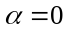, 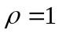 (a unit root process)

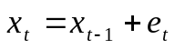
Note: This is a martingale process if e is not an 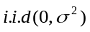 process.

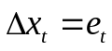 → the process is stationary in its first-difference.

The solution to the differential equation is:
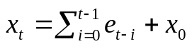 if 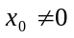

Properties of :

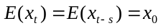 or 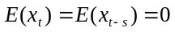 if 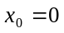. The mean of a random walk is constant.

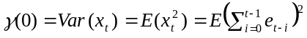=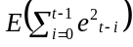 = 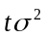 and

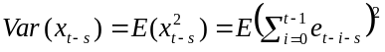=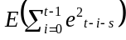=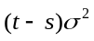.

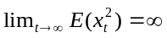. The variance explodes as t grows over time. RW is nonstationary.

Covariances and correlation coefficient:
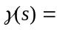Covar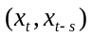
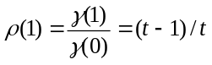, 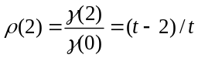, 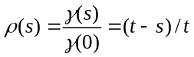

As 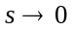 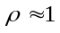and as , 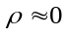. So, the correlation coefficient slowly dies out, though it takes a long time.

→ It may be difficult to distinguish the ACF of an AR(1) from random walk, especially if the autocorrelation coefficient is large. So ACF is not a useful tool with RW to determine if a process is nonstationary.

Variance and covariance are time dependent, thus the random walk process is non-stationary and needs to be first differenced to become stationary → it is called an I(1), or difference stationary (DS) process. This means that stochastic shocks have a nondecaying effect on the level of the series. They never disappear or die away over time slowly.

(ii) Random walk with drift: AR(1) model with 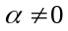,

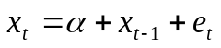

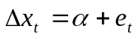 → the process is stationary in its first difference.

We saw that the solution to this differential equation is:
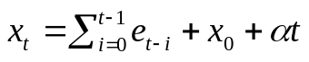

Thus x has a linear trend when we have a RW with drift. This process is the sum of two nonstationary processes:

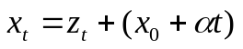

where 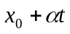= linear (deterministic) trend
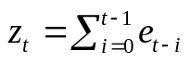 = stochastic trend (random walk without drift)

As t grows, the linear trend will dominate the random walk.

Since 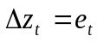, the first difference of x is stationary:
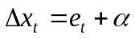 --mean constant 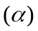, var constant (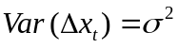), covar=0

A RW with drift is also a called difference stationary (DS) model.

(iii) ARIMA(p,1,q) model
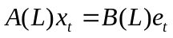
If A(L) has a unit root, B(L) all roots outside the unit circle, we can write the model as:
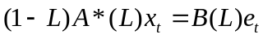 where polynomial A*(L)’s roots all lie outside the unit circle and it is of order p-1,
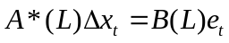
Now 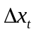 sequence is stationary since A*(L)’s roots all lie outside the unit circle.

With ARIMA(p,d,q), we can first-difference d times and the resulting sequence will be stationary as well.

First-differencing is used to make stationary a nonstationary series. It removes both the deterministic and the stochastic trends. But as we will see in the topic about cointegration, this makes the researcher lose valuable long-run information.

2. Trend-Stationary (TS) processes:
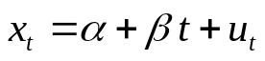, where u is a white-noise process.

Here nonstationarity is removed by regressing the series on the deterministic trend. The process fluctuates around a trend but it has no memory and the variation is predictable.
Ex: log(GNP) can be stationary around a linear trend. If you difference this process, then the resulting series are not well-behaved.

- First-differencing a TS process
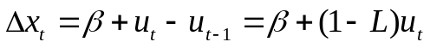
We are introducing a unit root in the MA component. Thus becomes noninvertible.

- Subtracting the deterministic trend: “detrending”
Substract the estimated values of x from the observed series 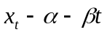. If nonstationarity is only due to deterministic trend, the resulting series 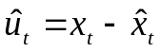will be a stationary process and thus can be modeled as an ARMA(p,q) process for ex.

More generally the trend function can be a polynomial with the degree to be determined by the AIC or SBC.
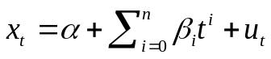

- Similarly, if you try to detrend a DS model, you end up adding a deterministic trend to the existing stochastic trend portion of the in the first difference :

- Warning: the problem with detrending is that it may be seriously misleading: a RW generates a lot of low frequency fluctuations. In a short sample, a drift may be wrongly interpreted as a trend or a broken trend. If you fit a trend to the series, which true representation is a RW, you would be estimating the wrong model. This is the problem with “technical analysis” in the stock or FX markets (head-and-shoulder patterns).

Illustration

Eviews graphs
TREND.PRG
BeveridgeNelson.WF

Generate three series: one DT (with deterministic trend) with 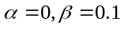and two with stochastic trends (ST1, ST2) whose difference is that error terms are from different drawings from the same distribution. STs are RW with a drift =0.1 .
smpl 1 1
genr ST1=0
genr ST2=0
smpl 2 200
series ST1= 0.1+ST1(-1) +nrnd
series ST2=0.1+ST2(-1)+nrnd
series DT= 0.1*@trend +nrnd

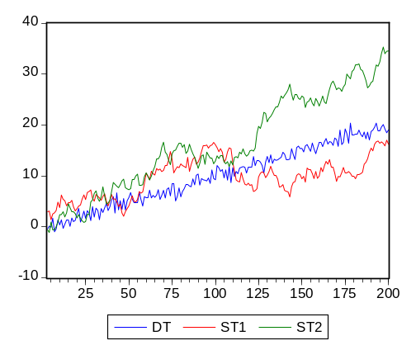

Unlike for the series DT, detrending the series ST1 and ST2 will not make the series stationary.

series dtdet=dt-0.1*@trend
series st1det=st1-0.1*@trend
series st2det=st2-0.1*@trend
plot dtdet st1det st2det

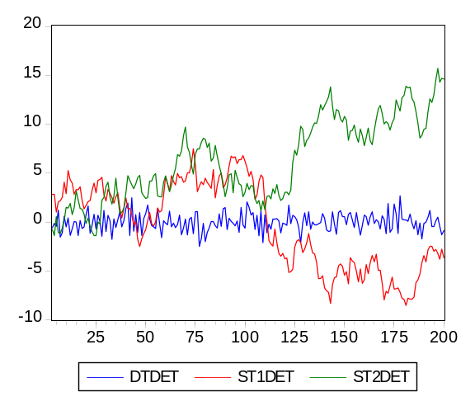

Try now first-differencing. All series become stationary.
series ddt=dt-dt(-1)
series dst1=st1-st1(-1)
series dst2=st2-st2(-1)
plot ddt dst1 dst2

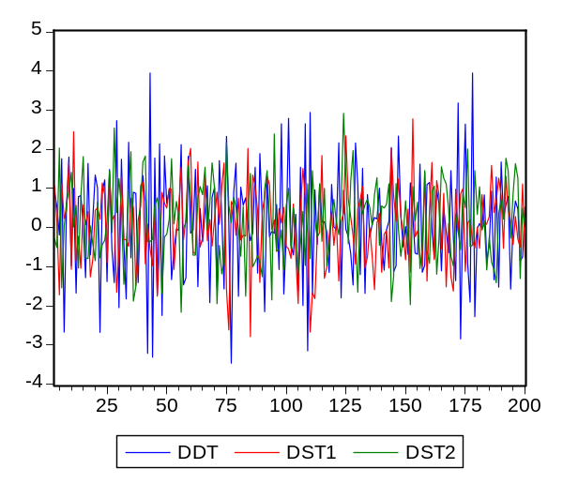

The TS model is a special case of DS model:
Consider a general form of a DS model:
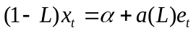 (the random walk with drift= simplified version where a(L)=1).

And a general form of a TS model:
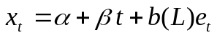, or:
where 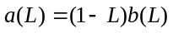, → a(L) has unit root.

** The main difference between the two models is that the MA part of the TS model has a unit root.

Both the DS (integrated variable) model and the TS (deterministic trend) model exhibit systematic variations.
Differences
- TS models: variation predictable → can be removed by removing the trend.
- DS models: variation not predictable → cannot be removed by detrending.

Alternative Representation of an AR(p) processes

This section shows that any polynomial of the process 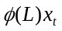 can be written
(3) 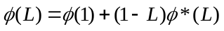

where

This is a useful representation that will be used to derive the Beveridge-Nelson decomposition.

Consider a polynomial
(4) 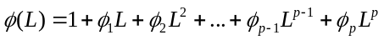

Define 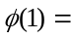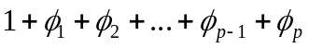
and 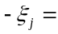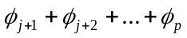 for j=0,1,2,…

The polynomial (3) is equivalent to:
(5) , because

Replace 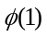and :
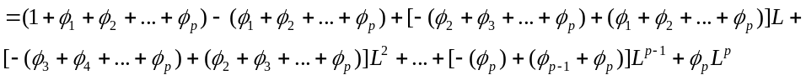

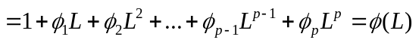

Thus:

A more elegant way of showing the same thing (Favero): C(L)=C(1)+(1-L)C*(L)

Consider C(L), a polynomial of order q.
Define a polynomial D(L) such that:
D(L)=C(L)-C(1), also of order q since C(1) is constant.

Thus D(1)=0, meaning that 1 is a root of D(L), and

D(L)=C*(L)(1-L)=C(L)-C(1)

thus C(L)=C(1)+(1-L)C*(L).

II. Decomposition of Univariate Time-series
Ref: Favero Ch.2, Enders Ch.4, Pagan online lecture notes #4

The idea is that it is informative to decompose a nonstationary sequence into its permanent and temporary (stationary) components.
Beveridge and Nelson (1981, JME): expressed an ARIMA(p,1,q) model in terms of random walk+drift+stationary components. They showed how to recover from the data the trend and the stationary components.

This idea goes back to measuring the “output gap” used to assess the business cycle or estimate the Phillips curve. Also, if you assume like in Blanchard and Quah that demand shocks affect out put temporarily while supply shocks affect it permanently, you can also infer the demand shocks from the temporary component. However, overall this is not a good way to approach this question, since the temporary vs permanent components should be model determined. Moreover, there are some problems associated with the assumptions behind trend extraction approaches since they are not unique.

Consider again equation 2
(2) 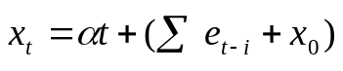
with x = deterministic trend due to drift + (difference stationary process).

BN decomposition further decomposes the 2nd term in the RHS into a stationary component and a random walk component.

Deriving the temporary vs. permanent effects (Favero p.51):

Consider the first difference of an integrated process:
(6) 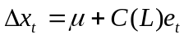 where 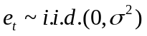 and C(L) is a polynomial of order q.

Define a polynomial D(L) such that D(L)=C(L)-C(1), also of order q since C(1) is constant. → D(1)=0, meaning 1 is a root of D(L) and hence we can express D(L) as:
D(L)=C*(L)(1-L)
Also → C(L)=C(1)+C*(L)(1-L)
D(L)=C(L)-C(1)

Using this result, we can thus rewrite (6) substituting C(L):
(7) 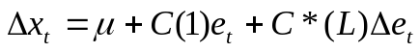.

Integrating this equation (i.e., divide both sides by (1-L)) we get:
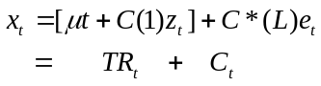

where z is a process such that 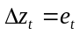, thus 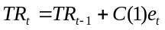
TR=deterministic trend + stochastic trend=permanent (random walk) component;
C = cyclical trend = temporary (stationary) component.

Alternative interpretation of the decomposition (Pagan, online lecture notes):
Rewrite (7) as:

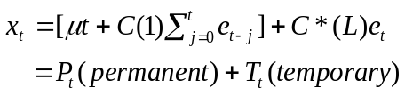

The term in the summation is an integrated series, which reflects permanent shocks → P is an I(1) process and T is an I(0) process since 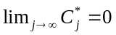.

This is what is called the

1. Beveridge and Nelson decomposition:

For any time-series 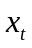 that is I(1), we can represent it as
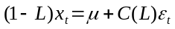 (6) with 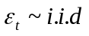 and C(L) a polynomial of order q,
and we can write
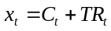
where
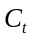=temporary (cyclical) component = 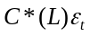
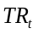=permanent (trend) component=deterministic trend+stochastic trend =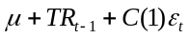 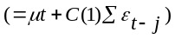.

To see this: apply C(L)=C(1)+(1-L)C*(L) in (3) to the polynomial C(L) in (6).
The equation can be written as

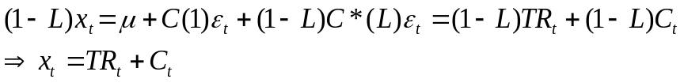.

Two features of B&N decomposition:
- The shocks to the permanent component C(1)e are white noise.
- The shocks to permanent and temporary components are perfectly negatively correlated.

Examples: find the cyclical and trend components in
1. ARIMA(0,1,1) process 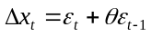 with 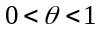
The BN decomposition gives:
With = and (1-L)=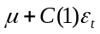.
From the example, we have:
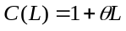
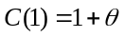
From 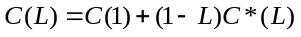
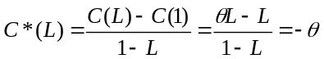
Thus 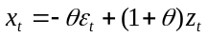 where 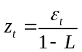, a process for which 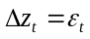.

2. An ARIMA(1,1,1) process 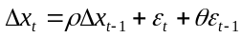 with
Rewrite the process as 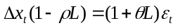 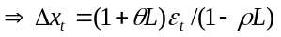
Thus 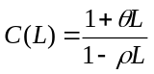 and 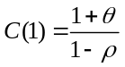

and 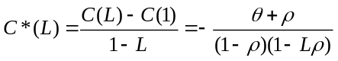

Hence,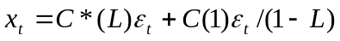= 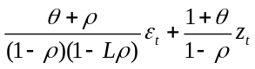. The longer the memory (higher rho), the bigger is the effect of the stochastic trend on the process.

3. An AR(1) process: 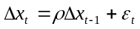
HW2: Find the transitory and the permanent components.
Show that the permanent component’s effect on the process is higher, the longer is the memory.
When the transitory component is measured by the Beveridge-Nelson decomposition,
and the growth rate is AR(1), show that the transitory component is proportional to the growth rate in x,

Procedure to use the BN technique in empirical studies:
Step 1: Estimate the first-difference of the series, and identify the best ARIMA model of the sequence. Get the error term and all the parameters in the constant in TR and C(1).
Step 2: Given an initial value for TR, compute the permanent component TR of the sequence.
Step 3: Compute the cyclical component by subtracting the permanent component from the observed values in each period.

Numerical Example
- Favero p.52
Suppose you estimated an ARIMA(2,1,1) model and got the following regression result:

How can we generate the permanent and the cyclical (transitory) components of this process? For this, we need to calculate the parameters in C(1), TR and compute C*(L).

Rewriting the model with lag operators, you transform it into an ARMA(1,1) model:

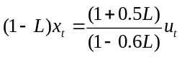

Using the expression in (6):

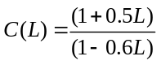 and C(1)=1.5/0.4
and 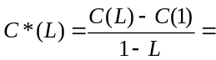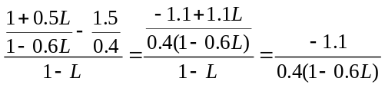

Thus the BN decomposition of the x process is:

= 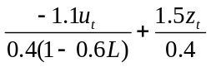 where 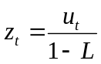 and 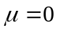

and 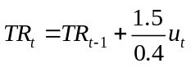.

We can compute the permanent and the cyclical (transitory) components (tr and cycle, respectively) in Eviews as follows:

Use bn.prg and bn.wf
smpl 1 2
genr x=0
smpl 1 200
genr u=nrnd
smpl 3 200
series x=x(-1) +0.6*x(-1)-0.6*x(-2) +u+0.5*u(-1)
smpl 1 2
genr TR=0
smpl 3 200
series TR= TR(-1)+(1.5/0.4)*u
genr CYCLE=X-TR
plot cycle TR x

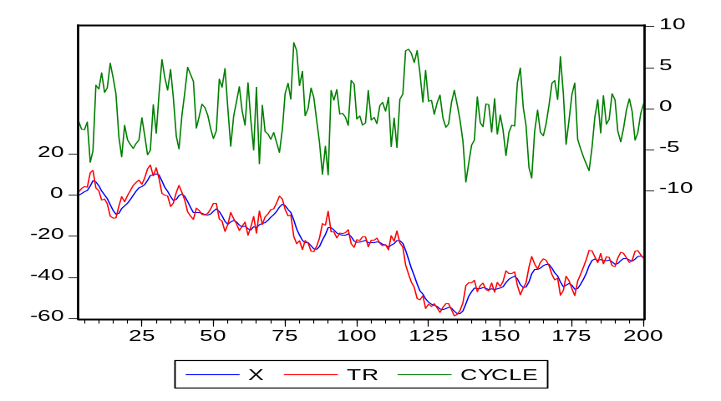

- REER_Enders: Canadian real exchange rate.
Workfile: reer_enders.wf
Program: bn.prg

Consider an ARIMA(1,1,1) model
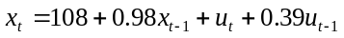. The model has an unstable AR root.

So fit the ARMA model
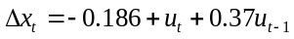 (eqreer)

Dependent Variable: CANADA-CANADA(-1)
Variable | Coefficient | Std. Error | t-Statistic | Prob.
C | -0.186171 | 0.343883 | -0.541381 | 0.5896
MA(1) | 0.370357 | 0.099292 | 3.729962 | 0.0003
R-squared | 0.114123 | Mean dependent var |  | -0.186517
Adjusted R-squared | 0.103941 | S.D. dependent var |  | 2.506556
S.E. of regression | 2.372716 | Akaike info criterion |  | 4.588163
Sum squared resid | 489.7908 | Schwarz criterion |  | 4.644087
Log likelihood | -202.1733 | F-statistic |  | 11.20779
Durbin-Watson stat | 2.020327 | Prob(F-statistic) |  | 0.001205
Inverted MA Roots | -.37

Root=-0.37 it is inside the unit circle, thus the ARMA model is invertible.
The residuals are nearly white noise, no serial correlation: DW=2 (can use it because there are no lagged dependent variable on the RHS), all autocorrelations and partial autocorrelations are close to zero.

Date: 10/03/07 Time: 09:26
Sample: 1980Q2 2002Q2
Included observations: 89
Q-statistic probabilities adjusted for 1 ARMA term(s)
Autocorrelation | Partial Correlation |  | AC | PAC | Q-Stat | Prob
. | . | | . | . | | 1 | -0.013 | -0.013 | 0.0154
. | . | | . | . | | 2 | 0.036 | 0.036 | 0.1344 | 0.714
. |*. | | . |*. | | 3 | 0.147 | 0.148 | 2.1585 | 0.340
. | . | | . | . | | 4 | 0.033 | 0.037 | 2.2604 | 0.520
. | . | | . | . | | 5 | 0.053 | 0.045 | 2.5293 | 0.639
. | . | | . | . | | 6 | 0.041 | 0.020 | 2.6949 | 0.747
. | . | | . | . | | 7 | -0.010 | -0.022 | 2.7040 | 0.845
. |*. | | . |*. | | 8 | 0.113 | 0.097 | 3.9707 | 0.783
. | . | | . | . | | 9 | 0.028 | 0.023 | 4.0524 | 0.852
.*| . | | **| . | | 10 | -0.188 | -0.201 | 7.6886 | 0.566
.*| . | | .*| . | | 11 | -0.099 | -0.152 | 8.7160 | 0.559
.*| . | | .*| . | | 12 | -0.062 | -0.078 | 9.1245 | 0.610
**| . | | **| . | | 13 | -0.239 | -0.213 | 15.210 | 0.230
. | . | | . | . | | 14 | 0.037 | 0.063 | 15.358 | 0.286
**| . | | .*| . | | 15 | -0.193 | -0.153 | 19.447 | 0.149
.*| . | | . | . | | 16 | -0.100 | -0.055 | 20.562 | 0.151
.*| . | | .*| . | | 17 | -0.071 | -0.074 | 21.134 | 0.173
. | . | | . |*. | | 18 | 0.025 | 0.148 | 21.204 | 0.217
.*| . | | . | . | | 19 | -0.093 | -0.001 | 22.196 | 0.223
.*| . | | . | . | | 20 | -0.063 | -0.037 | 22.663 | 0.252

Compute the cyclical and permanent components:

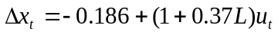

C(L)=1+0.37L C(1)=1.37 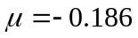

Thus 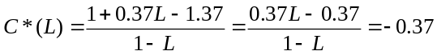 and therefore,

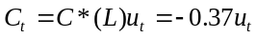 ---the cyclical (transitory) component.

---permanent component.

Then we can rewrite x in terms of its cyclical and permanent components as:
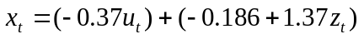

EVIEWS:
Generate the permanent and the transitory components of the x process.

The decomposition of a series into a random walk and a stationary component is not unique, BN is one way of doing it so, but there are also other ways, such as Hodrick-Prescott Filter as we will see below.

BN requires
(i) the correlation between the trend and the cyclical components to be -1,
(ii) var(trend)>var(the x series): the permanent component is more volatile than the series because the negative correlation between the trend and the cyclical component smoothes out the x sequence.

We can see this using the Example 1 where we got
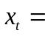
where and

Thus

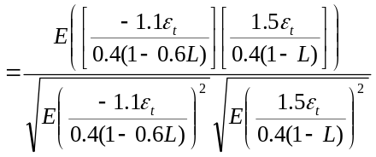 = -1

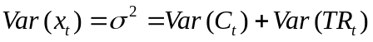
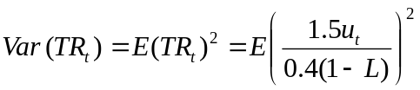 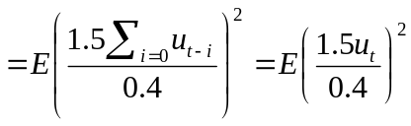 since 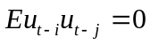
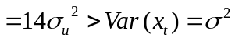

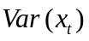= 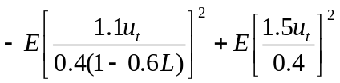

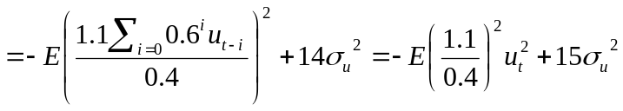
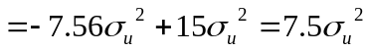

Hence 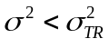.

If the innovation between the trend and the stationary component is not -1, but rather 0 (they are uncorrelated), but you use a BN decomposition, you would impose on the data an incorrect partitioning of the variances. But there is no way to know the identification from the data when you use univariate decomposition.

2. Hodrick-Prescott Decomposition (Filter)
This is another way of decomposing a series into its trend (permanent), TR and cyclical (temporary) components (x-TR). Vast applications in the real business cycle literature. The idea is to minimize variations around the trend (permanent component).

The minimization is done under the constraint of a penalty, represented by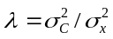, which penalizes variability in the growth component (TR) series. The larger the value of , the smoother is the solution series TR.

See Hodrick and Prescott (JMCB 1997) for an application to growth in GNP and aggregate demand’s components (all variables are in natural logs, so the change in TR corresponds to a growth rate).

Illustration
Workfile bn.wf
Select X, proc, HP filter. Call the smoothed series hptrendx, with 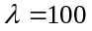.
Compare results with BN: trendHP is smoother than trendNB. If increase the maximum volatility will be that of the actual series x.

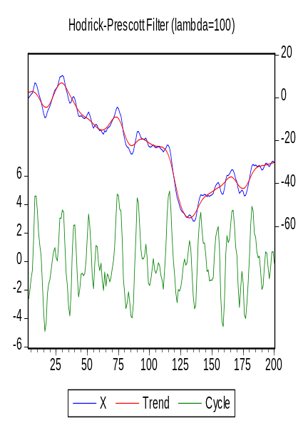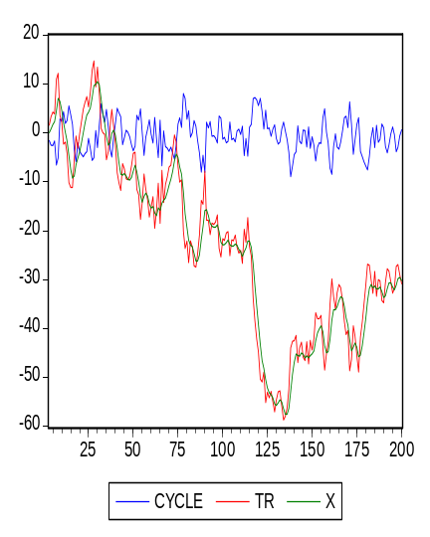
HP Filter BN decomposition

Both methods give different decompositions. Since we don’t have prior information on the relationship between innovations in the trend and the stationary components, the decomposition of the series into a permanent and temporary component is not unique.

The advantage of the HP filter is that it is applying the same trend to all the series you use. Therefore, it is often applied in business cycle analyzes where most series share the same stochastic trend. BN decomposition extracts a different trend from each series. The disadvantage of HP filter though is that since it smoothes the trend, it may introduce spurious volatility into the stationary component of the series.

Which method you want to use depends on the type of identification problem you are analyzing. Theoretical models imply that several time series share common stochastic trends. In empirical methodology this translates into multivariate models. Then we need to see if we are able to group series into common stochastic trends and look at whether this makes the trend is disappear: cointegration.

To consider whether different series with stochastic trends are cointegrated, we first need to look at the unit roots and unit root tests.

II. Unit roots and spurious regressions

We mentioned that many economic time series are nonstationary. This includes most NI statistics, goods and asset prices. Nonstationarity is usually due to a few causes, and it gets transmitted to all other variables.

- Productivity shocks: affect output and the real side of the economy.
- Monetary policy: a deviation of money supply from its LR constant growth, the log of money supply is a random walk with drift:
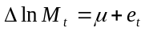
then all nominal variables and nominal prices become nonstationary.
- Individual budget constraints:
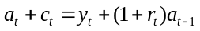 a=assets, c=consumption, y=income, r=interest rate.
Solving for a:
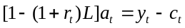 or 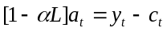
But 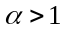 (root>1) thus the system is unstable (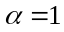 is a random walk) thus I(d).

Implications of nonstationarity in economics and finance

- Model building:
Nonstationary series are more volatile than stationary series
Series with drift terms tend to be more volatile around strong trends.
If we have nonstationary processes with drifts, the other series also must exhibit the same behavior to have meaningful estimates. For ex: you cannot explain GDP with unemployment since GDP has a trend while the other variable does not. If the dependent variable is nonstationary, you need to have at least a subset of the independent variables to be nonstationary as well.

- Econometrics
If data are nonstationary, then the sampling distributions of coefficients estimates may not be well approximated by the Normal distribution. This is particularly true if the series have a drift.

Suppose you regress one independent random walk process on another random walk process, you may end up getting high R2 and significant estimates but this result is called spurious, and meaningless since the two series have no relation (Granger and Newbold, 1974, J of Econometrics).
Consider:
(8) 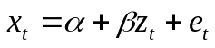

The traditional regression methodologies require 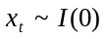, 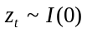, and 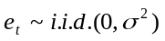. If e is nonstationary, then estimates are meaningless because shocks will have permanent effects, and thus the regression will have permanent errors.

Suppose that x and z are random walk with 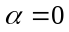.
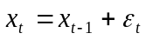
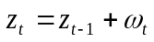.

Thus 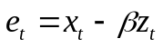 = 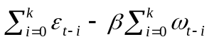assuming initial conditions are 0.
Note that the first moment of e is not constant but instead: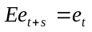
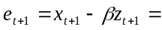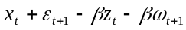 = 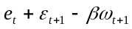.

Thus also: .

The second moment increases with t, and also not constant.
Hence the traditional statistical inference methods, such as OLS, are not valid. This problem will not disappear in large samples either, making asymptotic results not applicable also.

Illustration
USUK.wf
Run series LCUS on c LYUK
EqTable2_2

Dependent Variable: LCUS
Method: Least Squares
Date: 01/02/07 Time: 16:17
Sample (adjusted): 1959Q2 1998Q1
Included observations: 156 after adjustments
Variable | Coefficient | Std. Error | t-Statistic | Prob.
C | -5.612166 | 0.162908 | -34.44987 | 0.0000
LYUK | 1.208546 | 0.014643 | 82.53580 | 0.0000
R-squared | 0.977893 | Mean dependent var |  | 7.829120
Adjusted R-squared | 0.977750 | S.D. dependent var |  | 0.351691
S.E. of regression | 0.052460 | Akaike info criterion |  | -3.044783
Sum squared resid | 0.423821 | Schwarz criterion |  | -3.005682
Log likelihood | 239.4931 | F-statistic |  | 6812.158
Durbin-Watson stat | 0.138834 | Prob(F-statistic) |  | 0.000000

High R2, and t stats. but meaningless results. Spurious regressions.

See if the series LCUS and LYUK are AR(1).
Eqlcus and eqlyuk

Dependent Variable: LCUS
Variable | Coefficient | Std. Error | t-Statistic | Prob.
C | 9.964851 | 0.595449 | 16.73503 | 0.0000
AR(1) | 0.996284 | 0.001022 | 975.2605 | 0.0000
R-squared | 0.999836 | Mean dependent var |  | 7.836301
Adjusted R-squared | 0.999835 | S.D. dependent var |  | 0.355190
S.E. of regression | 0.004563 | Akaike info criterion |  | -7.929080
Sum squared resid | 0.003248 | Schwarz criterion |  | -7.890313
Log likelihood | 628.3973 | F-statistic |  | 951133.0
Durbin-Watson stat | 1.366495 | Prob(F-statistic) |  | 0.000000
Inverted AR Roots | 1.00

Dependent Variable: LYUK
Variable | Coefficient | Std. Error | t-Statistic | Prob.
C | 0.049911 | 0.049873 | 1.000764 | 0.3185
LYUK(-1) | 0.996123 | 0.004486 | 222.0758 | 0.0000
R-squared | 0.996887 | Mean dependent var |  | 11.12186
Adjusted R-squared | 0.996867 | S.D. dependent var |  | 0.287769
S.E. of regression | 0.016108 | Akaike info criterion |  | -5.406311
Sum squared resid | 0.039956 | Schwarz criterion |  | -5.367210
Log likelihood | 423.6923 | F-statistic |  | 49317.67
Durbin-Watson stat | 2.296729 | Prob(F-statistic) |  | 0.000000

In both equations 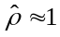, and the error terms seem i.i.d. with zero mean and constant or finite variance, thus equations are close to random walk.
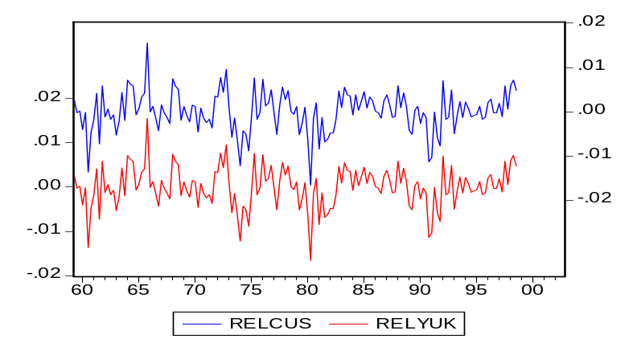

This leads to the solution to (8) with a stochastic trend. In (8) we are thus regressing a trending variable on another trending variable, hence is high.

Residuals from running LCUS on LYUK show that the stochastic error term is still present. So this is a spurious regression.

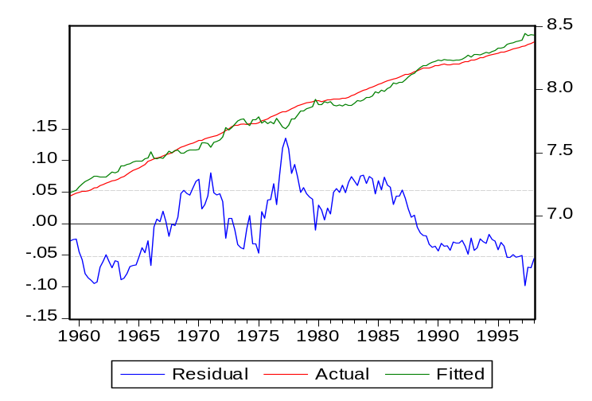

Several cases:

 |  | 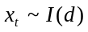
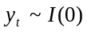 | Classical regression model appropriate | Classical regression model not appropriate. Spurious regression.
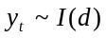 | Classical regression model not appropriate, spurious regression. Residual sequence has stochastic trend. | If residual sequence has stochastic trend, spurious regression.
 |  | If residual sequence is stationary, series are cointegrated.
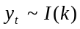 | Classical regression model not appropriate. Spurious regression

(Enders)

Important to check if the series are nonstationary. Tests such as Dickey-Fuller (DF) and Augmented Dickey-Fuller (ADF) have been widely used to check the stationarity of the processes.

Dickey-Fuller (DF) test (1979)
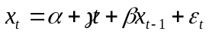 where is NID
But this test is valid only for AR(1) processes. If there is higher order correlation, then we need to use the ADF test.

Augmented Dickey-Fuller (ADF) or Said-Dickey test
Consider the following AR(p) equation:
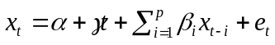
Assume that there is at most one unit root, thus the process is unit root nonstationary. We will reparameterize this equation. For this, consider an AR(2) process and reparameterize it (subtract 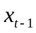 from LHS and RHS, subtract and add 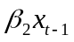 to RHS):

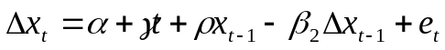

And for AR(p):
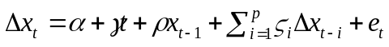,

where 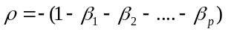 and 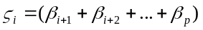for i=1, 2, 3,…, p-1.

This is the augmented version of the DF test (for DF all 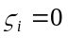). It is general enough to be asymptotically valid when there is an MA component, if there are sufficient lagged difference terms.

Null hypothesis: 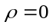. Alternative: 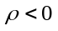
If not rejected then x is nonstationary.
The test is evaluated with the t-ratio: 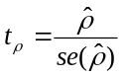.
(Note: for p=1, 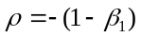, and the test is equivalent to whether there is a stable root or not.)

This statistics does not follow the conventional Student’s t-distribution. In both tests critical values are calculated by Dickey and Fuller and depend on whether there is an intercept and/or deterministic trend, whether it is a DF or ADF test. Eviews uses the more recent MacKinnon estimates for critical values, which are valid for any sample size.

Intercept and deterministic time trend
The intercept and trend depend on the alternative hypothesis.
- If the alternative is that the series is mean-zero stationary, then there is no intercept. Unlikely in macroeconomics series.
- If alternative is constant-mean stationary, then include an intercept. This is a good assumption for time series that do not grow over time.
- If the alternative is that the series is trend stationary, then include a constant and a linear trend. This specification represents most macroeconomic time series that are growing over time.

Choice of lag length
- Sequential t/F-statistics approach: start from a large number of lags, and reestimate by reducing by one lag every time. Stop when the last lag is significant. Quarterly data: look at the t-stats for the last lag, and F-stats for the last quarter. Then check if the error term is white noise.

- Information Criteria: AIC or SBC or HQC

** Note that the ADF test is not robust to the choice of p.

Phillips-Perron (PP) test (1998)
It uses a nonparametric method to correct for the serial correlation of . PP make the adjustment to both DF and ADF tests, and call their adjusted tests Z(t) and 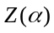, respectively and they have the same asymptotic distribution as the DF and the ADF tests.
- Advantage: more powerful than ADF.
- Disadvantage: more severe size distortions than ADF tests (the size of the test in small samples is significantly different from the size of the test obtained from asymptotic theory).

Kwiatkowski, Phillips Schmidt and Shin (KPSS) test (1992)
Often we model variables assuming that the variables are stationary. The tests so far have the null of nonstationarity. KPSS test is one of the first ones that sets the null that the series is trend stationary. It assumes that the series is (trend) stationary under the null. It uses LM statistics and the critical values for this are based on asymptotic results given in KPSS.

Procedure for unit root test:
- Decide on the model: whether or not a constant/time trend is required. If there is no trend, then the alternative hypothesis should be that the process is non-zero mean and without trend. If there is a trend, then the alternative is that the process is trend stationary with a non-zero constant.
- Choose the maximum order of lags.
- If the t-statistics is negative and greater than the critical value in absolute value, reject the null of unit root.

Problem with the nonstationarity tests:
The power of the DF and ADF tests are very low, i.e. they can not reject the null of nonstationarity too often (suggest that there is a unit root).

